**IT-214 (DBMS)**

**Lab-10 G1 S2**

**Software Requirements Specification**

**For**

**Ministry of Education**

**Team ID: 2.4**

Team Members

**Poojan Patel 202001028**

**Keshav Somani 202001029**

Table Of Contents

**1.FINAL SRS**

1. **Introduction**

1.1. Purpose

1.2. Intended Audience

1.3. Suggested Readings

1.4. Product Scope

1.5. Description

1. **Fact Findings**

2.1. Background Readings

2.1.1. Description

2.1.2. References

2.1.3. Requirements

2.1.4 Interview

2.1.5 Questionnaire

2.1.6 Observations

1. **Fact-finding chart**
2. **List of requirements**
3. **User Categories and Privileges**
4. **Assumptions**
5. **Business Constraints**

**2.NOUN AND VERB ANALYSIS**

1. **Noun (& Verb) Analysis.**

2.1. List of All Nouns and Verbs

2.2. Accepting noun list

2.3 Rejecting nouns and verbs list

2.3.1 Rejected nouns list

2.3.2 Rejected verbs list

1. **E.R. Diagram**

3.1 Version 1

3.2 Version 2

1. **Finalizing E.R. Diagram**

4.1 Identifying Entity Type

4.2 Identifying Relationship Type

1. **Final E.R. Diagram**

**3.FINAL NORMALIZATION**

1. **E.R. to Relational Model And Normalization**
2. **DDL Scripts**
3. **Triggers and Their Functions**

**4.SQL Queries**

**5.Final Front-end related documents**

**FINAL SRS**

**INTRODUCTION**

1.1 **PURPOSE**

This document aims to help developers and end users understand the purpose and features of the system and the interfaces of the system of the education ministry. The constraints under which it must operate.

The primary purpose of this system is to ease the complexity of our country's ministry of education, which was previously managed by the workforce.

The aim of this database is as follows:

1. Integration of the Ministry of Education and political parties during that time and their terms of service.
2. Managing information of schools and colleges working under the multiple states and central bodies.
3. Provide statistics for a better analysis of the efficiency and growth of children in schools and departments.
4. Consistently update the information of all departments.
5. Authorization provide controlled access of secured information to a department regarding its requirements.
6. Providing organized information to the citizens of India.

1.2 **INTENDED AUDIENCE**

1. **Developer:** Developers can access the database through API for production and learning purposes, create statistical analysis, and provide efficient employee services to manage data.
2. **End User:**  Creating an authorization system to classify end users for accessing and managing the data. The end users are as follows:
   1. **School/college Principal:** Here, the principal can change the information regarding the school/college, like the number of students enrolled, midday meal scheme, number of instructors, etc.
   2. **Head of the department:** The head of the department is given the authorization to change the data of any table in the database.
   3. **Citizens:** Normal citizens can only read the database's data through APIs.

1.3 **SUGGESTED READINGS**

1. [EDUCATIONAL STATISTICS AT A GLANCE](https://www.education.gov.in/sites/upload_files/mhrd/files/statistics-new/ESAG-2018.pdf)
2. ANNUAL [REPORT 2018-2019](https://www.education.gov.in/sites/upload_files/mhrd/files/document-reports/annual_rpt_eng_1819.pdf)

1.4 **PRODUCT SCOPE**

1. Provides access to only required data to a specific department and controls the data accessed by multiple departments under the education ministry.
2. Providing the count of students teacher each year to study the enrollment rate of both teachers and students also helps to understand the demand for teachers in each region of India.
3. It will help to study how much the government schemes are active in different regions of India.
4. Providing information to the user through API service.
5. Deliver an Electronic and efficient Workplace for the education ministry.

1.5 **DESCRIPTION**

1. This contains relevant information about the education ministers of each state in India and the prime minister's name during that term, and the party they belong to.
2. This project will take care of numerous activities being done under MOE daily, including the listing of schools and colleges and the government under which they function and their establishment. It contains details about the government’s primary schools, the count and attendance of children studying in school, their standards, the beneficiaries of government programs like midday meals, and the count of male and female teachers/professors teaching in each school.
3. To count the number of government institutions(schools and colleges) present in every state of India, along with each state’s education minister and their term of service.
4. Contains the details of government primary schools in each region or village, or city.
5. Contains a count of the number of students in each school and also the number of teachers in each school.
6. Contain information regarding different government schemes registered in each school.
7. Contain authorization for each user(admin, principal and public) and update for administrative users.
8. Contains ID, cast, age, gender, passing and enrolment year, standard, guardian name financial background-wise information of students in their respective schools/college.
9. Contains information about all the facilities available in each school.
10. Differentiating the schools based on the region, pincode, urban and rural, board, located in each state and city , affiliation number to identify each school's requirement.

**FACT-FINDING**

2.1 **BACKGROUND READING**

2.1.1 **DESCRIPTION**

1. **Description of First Reading:** In this reading, we are given the whole education statistics of our country. In this reading, there are more than 50 data sets merged in tabular form for ease of understanding from the primary and secondary education department, the number of enrolled schools, demand and supply analysis of teachers, and the progress of schemes implemented by the ministry of India. This reading is also helpful for studying literacy rates in India.
2. **Description of Second Reading:** in Chapter 2 of this reading, named “NATIONAL PROGRAMME OF MID-DAY MEAL IN SCHOOL,” we are given all the information about the government's mid-day meal scheme. We are given data on cost per meal in states and union territories of India. We are also given data about how many students are allocated to this scheme daily, foodgrain allocated, budget allocation, and total expenditure for this scheme.

2.1.2 **REFERENCE**

1. [EDUCATIONAL STATISTICS AT A GLANCE](https://www.education.gov.in/sites/upload_files/mhrd/files/statistics-new/ESAG-2018.pdf)
2. ANNUAL [REPORT 2018-2019](https://www.education.gov.in/sites/upload_files/mhrd/files/document-reports/annual_rpt_eng_1819.pdf)

2.1.3 **REQUIREMENTS**

1. Starting with the student details table, we have to form a table that should contain the following information:
   1. Student Name
   2. Age
   3. Roll Number
   4. Financial Background
   5. Cast
   6. Gender
   7. Enrollment date
   8. School/College Name
   9. Standard
   10. Guardian Name
2. Then we have to make a table consisting of school details which consist of the following information:
3. School/College Name
4. Affiliation No
5. Government Schemes
6. Number of students enrolled
7. State/Central
8. Number of teachers/ professor
9. Attendance
10. Board

3)A table that consists of information about the education minister of each state the information is as follows:

a)Name b)State/Central

c)Political Party Name d)Prime Minister

e)Term Year

2.1.4 **INTERVIEW**

1) **INTERVIEW PLAN**

**System:** DBMS for Ministry of Education

**Project Reference:** PP/KS/2022/09

**Participants:** Mamta Patel (Principal)

Keshav Somani Poojan Patel(Interviewee IT department)

**Date:** 27/09/2022

**Time:** 16:30

**Duration:** 30 minutes

**Place:** School

# **Purpose of Interview:**

Preliminary meeting to identify the variables essential to identify improvement in, board, and school education system, and which factors are used to measure this quantity.

# **Agenda:**

The agenda of this meeting is to understand the measuring components that describe the growth of education at a lower level and implement the same in our database.

# **Documents to be brought to the interview:**

Rough plans of the building and the latest annual educational statistics report.

**INTERVIEW SUMMARY**

1. The gross enrolment rate (GER) is essential to track enrolment growth for both boys and girls. It is improving faster for girls than boys.
2. There is an increase in the participation of females at all levels.
3. The enrollment of students in each level of education is increasing each year substantially.
4. Children's Attendance will track the quality of education in that classroom.
5. The literacy rate for both males and females is increasing year by year, which helps to lift individuals out of poverty.
6. The number of teachers enrolled increases each year. Appointing more women in the teaching profession.
7. There has been an increase in the percentage of schools with facilities like clean drinking water, toilets, textbook availability, etc.
8. The Mid-day meal scheme funds are utilized more effectively by the schools.

2) **INTERVIEW PLAN**

**System:** DBMS for Ministry of Education

**Project Reference:** PP/KS/2022/09

**Participants:** Keshav Somani (Interviewee IT department)

Poojan Patel (Analytics Head-MOE)

**Date:** 29/09/2022

**Time:** 17:30

**Duration:** 60 minutes

**Place:** Education Department Office

# **Purpose of Interview:**

Preliminary meeting to identify there is improvement in our country's education system, and which factors are used to measure this quantity.

# **Agenda:**

The agenda of this meeting is to understand the measuring components that describe the growth of the education system and implement the same in our database.

# **Documents to be brought to the interview:**

Rough plan of the building and latest annual educational statistics report.

**INTERVIEW SUMMARY**

1. Tracking the schools in different regions is essential.
2. Number of children per km attending school will keep track of literacy density.
3. The gross enrolment rate (GER) is vital to track enrolment growth for both boys and girls.
4. Schools should be differentiated for rural and urban in every state with the student count.
5. The number of teachers enrolled increases each year. Appointing more women in the teaching profession.
6. The gender parity index (GPI) will help us track girls' and boys' ratios efficiently. For the maximum states of India, it is increasing.
7. The government has been increasing state-wise fund allocation for Sarva Siksha Abhiyan (SSA) year by year.
8. Tracking of different government schemes for a school. The schools utilize the Mid-day meal scheme funds more effectively..
9. The number of teachers enrollment increases each year. Appointing more women in the teaching profession.

2.1.5 **QUESTIONNAIRE**

After conducting interviews, we decided to have a small survey only for school principals. The questions are as follows:

[Link to Survey](https://forms.gle/k5t7zM5HkkzTkW6v7)

1. 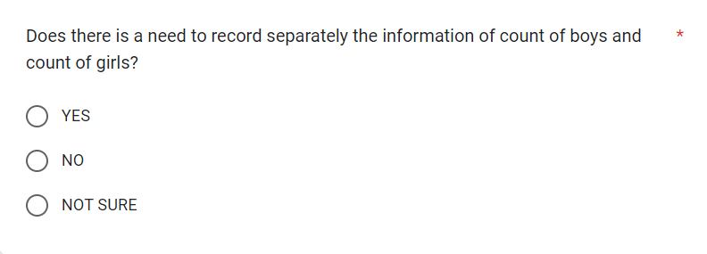

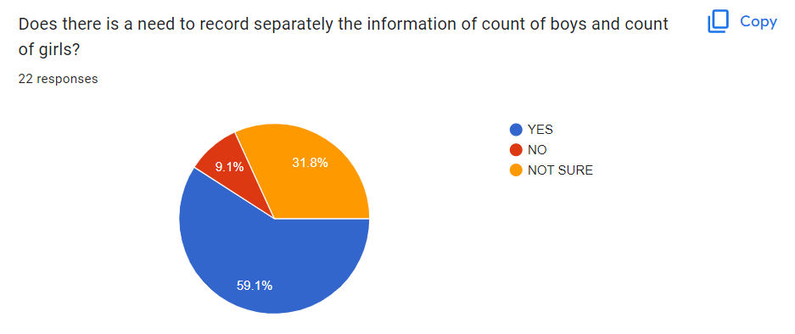

**Intention of Question:** To get to know how vita is boys and girl count separately instead of the total count.

2. 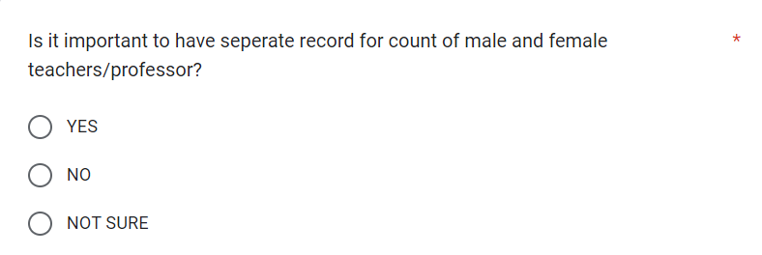

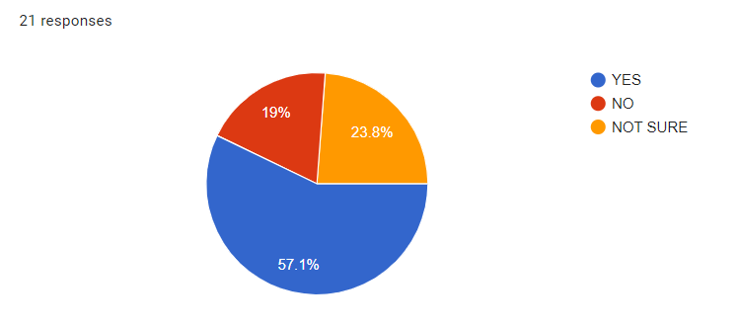

**Intention of Question:** To know how important male and female instructor counts are, separately instead of their total count.

3. 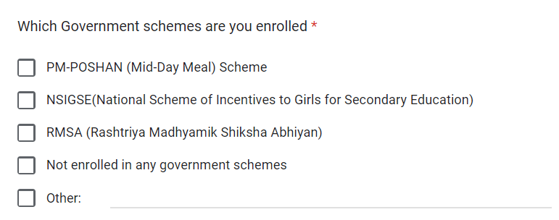

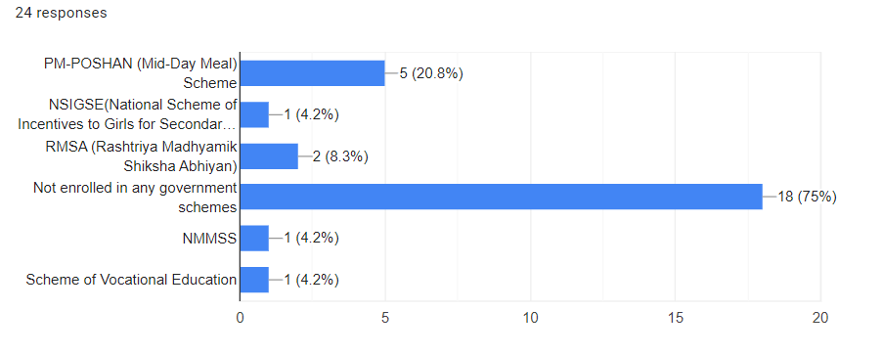

**Intention of Question:** To know which government schemes are more active than others.

4. 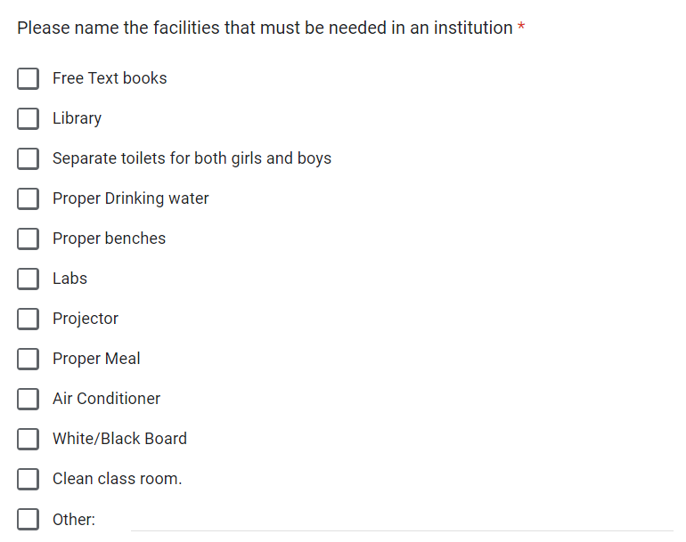

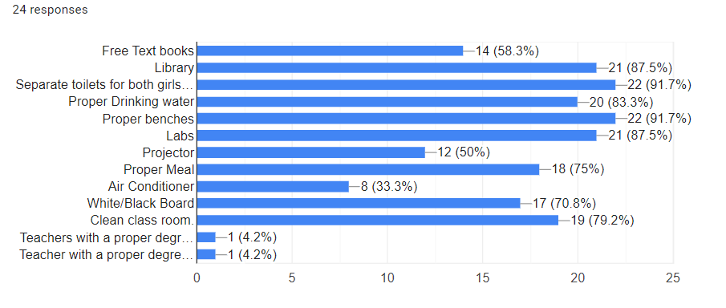

**Intention of Question:** To get to know , what are the bare minimum facilities that must be available in any institution.

**Requirements Gathered:**

1. Tracking down the boy's and girl's counts is important for a better understanding of the enrolment of students.
2. The count of male and female instructors is also critical.
3. Tracking different government schemes will help us identify the most active ones.
4. The essential facilities are required in schools/institutions.

2.1.6 **OBSERVATIONS**

**EDUCATION MINISTRY: Observations**

**System:** DBMS for Ministry of Education

**Project Reference:** PP/KS/2022/09

**Observations by:** Keshav Somani Poojan Patel

**Date:** 27/9/2022 **Time:** 14:30

**Duration:** 45 minutes **Place:** DAIICT

**Observations:**

1. We need to track the count of males and females separately in both students and teachers.
2. We must keep track of all facilities available in all schools.
3. We must keep track of each school's government schemes.
4. Schools should be differentiated based on the region in each state to analyze each school's requirements.
5. Aggregate Attendance is required in every school.
6. Percentage of change in Enrollment of students is an essential factor.

**FACT FINDING CHART**

| **Objective** | **Technique** | **Subject** | **Commitment** |
| --- | --- | --- | --- |
| To get the background on the ministry of education | Background Readings | Annual Reports  [EDUCATIONAL STATISTICS AT A GLANCE](https://www.education.gov.in/sites/upload_files/mhrd/files/statistics-new/ESAG-2018.pdf) | 1 Day |
| To identify the variables for studying a school's education system. | Interview | Principal of the school  (only 1) | 2 x 1 hour |
| To identify the variables for studying a country's education system. | Interview | Analytics Head (MOE) | 2 x 1 hour |
| Understand the observation of interviews. | Observation | Interview | 1.5 hours |
| to have a small survey only for school principals | Questionnaire | Google Form | 2 x 1.5 hours |
| To find out the other requirements. | Observation | Questionnaire, Both Interviews | 2 x 1.5 hours |

**LIST OF REQUIREMENTS**

1. Details of Student enrolled in every school
   1. Student Name
   2. Student ID
   3. Age
   4. Roll Number
   5. Financial Background
   6. Cast
   7. Gender
   8. Enrollment year
   9. Standard
   10. Guardian Name
   11. Pass Out
2. Then we have to make a table consisting of all school details which consist of the following information:
3. School/College Name
4. Affiliation No
5. Government Schemes
6. Number of male students
7. Number of female students
8. State/Central
9. Urban
10. Number of male professor/teacher
11. Number of female professor/teacher
12. Attendance
13. Board
14. Is primary
15. City
16. Enrollment Rate Male
17. Enrollment Rate Female

3) For each school we have to create a table for faculty which consists of the following information:

a) Name

b) ID

c) Age

d) Gender

4) We have to store different facilities for each and every school. It consists of the following information:

a) Enrollment Number

b) Facility Name

c) Year

5)We will need to store ministry information of each state, the information is as follows:

1. Name
2. State/Central
3. Political Party Name
4. Prime Minister
5. Term Year

6) We will need the information that which schools consist of which government schemes the information it contains are as follows:

a)Affiliation Number

b)Government scheme name

**USER CHARACTERISTICS**

**USER CHARACTERISTICS**

1. **Public User:** Normal/end users will be given the authority to only read the data for analysis purposes. The data will be available through API services so that developers can use it efficiently with security as well as reliability. The API can be further used to analyze the data in the form of graphs, charts, etc. The tables available to read can be responses of all the principals of school/college regarding only the information of count of males and females, government schemes that schools are enrolled, and facilities that are present in all the schools.
2. **School/college principal:** Here, the principal is given the authority to view, update and insert new data in the tables such as the student table, school table, facilities table, government schemes table, etc.
3. **Administrative user:** The admin of the database has authority to view, update, insert and delete all the data in the database.

**ASSUMPTIONS**

During the project, we assume some factors to be valid for developing a strategy, making decisions, and maintaining the database.

1. **Human Related:** During student and teacher Enrollment, admission Staff correctly obtains their data, and the data provided is True.
2. **Human-Computer interaction Related:** Enrollment Data entered by admission staff in the Database is Valid.
3. MOE's IT department has all the hardware required to support the intended user load.

**BUSINESS CONSTRAINTS**

1. In the student table, the roll number of each student should be different to identify each student.
2. There should not be any empty entries in the student table.
3. In the school table, each school's affiliation number should be unique to distinguish each school.
4. Their government scheme name should be from all government scheme tables only, not any invalid scheme, and the affiliation number corresponding to each table should be from the school information table only.
5. In the faculty table, the ID of each faculty should be different in order to identify each faculty.
6. In the facility table, the enrollment number corresponding to each facility should be from the school's information table only.

**REFERENCES**

**1)**<https://www.measureevaluation.org/resources/publications/tl-19-34/at_download/document>

**2)**<https://www.studocu.com/in/document/st-josephs-college-autonomous/bachelors-of-commerce/student-management-system-srs/17638223>

**NOUN AND VERB ANALYSIS**

2.1 **List of all nouns and verbs**

| **Noun** | **Verb** |
| --- | --- |
| Education | Belongs |
| minister |  |
| name |  |
| prime |  |
| party |  |
| State | located |
| India |  |
| Term Year |  |
| System |  |
| activities | performed |
| MOE | is(Admin), authorize users, control departments |
| School | use(system), update(information) |
| primary |  |
| children | studies |
| colleges |  |
| government |  |
| Region | Belongs |
| Urban |  |
| cities | located |
| rural |  |
| Pincode |  |
| beneficiaries |  |
| programs |  |
| Mid-day meal |  |
| teachers | teaches |
| professor | Count, contains |
| institutions |  |
| schemes | registered |
| students |  |
| Male | Count, contains |
| Female | Count, contains |
| user | use(system), view, modified, delete |
| Administrative | Authorize |
| ID |  |
| caste |  |
| gender |  |
| Standard |  |
| Financial background |  |
| Enrolment |  |
| year |  |
| facilities | available |
| age |  |
| Guardian |  |

2.2 **ACCEPTED NOUN LIST**

| **Candidate entity**  **set** | **Candidate attribute**  **set** | **Candidate relationship**  **set** |
| --- | --- | --- |
| Students | Enrollment year, standard, age, pass out, name, guardian name, financial background, cast, id, gender | studies |
| School | primary, affiliation number, name, urban/rural, board, primary | beneficiaries, available, teaches, located |
| Education minister | Prime minister, term year, name, ID | belongs |
| Party | Name, party id | belongs |
| facility | Facility, affiliation number | available |
| Government Schemes | Scheme, Affiliation number | beneficiaries |
| Teacher | Gender, Name, Affiliation no., ID | teaches |
| Cities | Name, Pincode | located |
| State | state_name | Located, located, belongs |
| Address | State, city, pincode, affiliation no. | located |
|  |  |  |

2.3 **Rejected Nouns and Verbs list**

2.3.1 **Rejected Noun List**

| **Noun** | **Reject Reason** |
| --- | --- |
| name | Attribute |
| prime | Attribute |
| India | Irrelevant |
| Term Year | Attribute |
| System | vague |
| activities | irrelevant |
| MOE | duplicate |
| Primary | Attribute |
| Children | duplicate |
| colleges | duplicate |
| region | duplicate |
| urban | attribute |
| rural | attribute |
| beneficiaries | association |
| programs | general |
| Mid-day meal | irrelevant |
| professor | duplicate |
| institution | duplicate |
| Male | vague |
| Female | vague |
| user | irrelevant |
| Administrative | Irrelevant |
| ID | Attribute |
| caste | Attribute |
| gender | Attribute |
| Standard | Attribute |
| Financial background | Attribute |
| Enrolment | Attribute |
| year | Attribute |
| age | Attribute |
| Guardian | Attribute |

2.3.2 **Rejected verbs list**

| **Verb** | **Reject Reason** |
| --- | --- |
| performed | irrelevant |
| Count | irrelevant |
| contains | duplicate |
| is(Admin), authorize users, control departments | Vague |
| use(system), update(information) | Vague |
| registered | duplicate |
| view, modified, delete | vague |
| Authorize | vague |

4.1 **IDENTIFYING ENTITY TYPES**

| **Entity Name** | **Entity Type** | **Relationship Type** |
| --- | --- | --- |
| Student | Strong entity | Simple Association Link |
| School | Strong entity | Simple Association Link |
| Teachers | Strong entity | Simple Association Link |
| Government Schemes | Weak entity | Simple Association Link |
| Facility | Weak entity | Simple Association Link |
| Address | Weak entity | Simple Association Link |
| State | Strong entity | Simple Association Link |
| Cities | Weak entity | Simple Association Link |
| Education minister | Strong entity | Simple Association Link |
| Party | Strong entity | Simple Association Link |

4.2 **Identifying Relationship types**

| **Candidate entity**  **set** | **Candidate attribute**  **set** | **Candidate relationship**  **set** |
| --- | --- | --- |
| Students | Enrollment year, standard, age, pass out, name, guardian name, financial background, cast, id, gender | studies |
| School | primary, affiliation number, name, urban/rural, board, primary | beneficiaries, available, teaches, located |
| Education minister | Prime minister, term year, name, ID | belongs |
| Party | Name, party id | belongs |
| facility | Facility, affiliation number | available |
| Government Schemes | Scheme, Affiliation number | beneficiaries |
| Teacher | Gender, Name, Affiliation no., ID | teaches |
| Cities | Name, Pincode | located |
| State | state_name | Located, located, belongs |
| Address | State, city, pincode, affiliation no. | located |

**Relationship types**

| **Relationship Name** | **Relationship Type** |
| --- | --- |
| Studies | Binary |
| Teaches | Binary |
| beneficiaries | Binary |
| Available | Binary |
| located | Binary |
| belongs | Ternary |

| **Entity Name** | **Relationship Name** | **Participation** |
| --- | --- | --- |
| Student | studies | Total Participation |
| School | beneficiaries | Partial Participation |
| School | studies | Partial Participation |
| School | located | Partial Participation |
| School | located | Total Participation |
| School | teaches | Partial Participation |
| Teachers | teaches | Total Participation |
| Government Schemes | beneficiaries | Total Participation |
| Facility | available | Total Participation |
| Address | located | Total Participation |
| State | located | Partial Participation |
| State | located | Total Participation |
| State | belongs | Total Participation |
| Cities | located | Total Participation |
| Education minister | belongs | Total Participation |
| Party | belongs | Total Participation |

**E.R. DIAGRAM**

3.1 **Version 1**

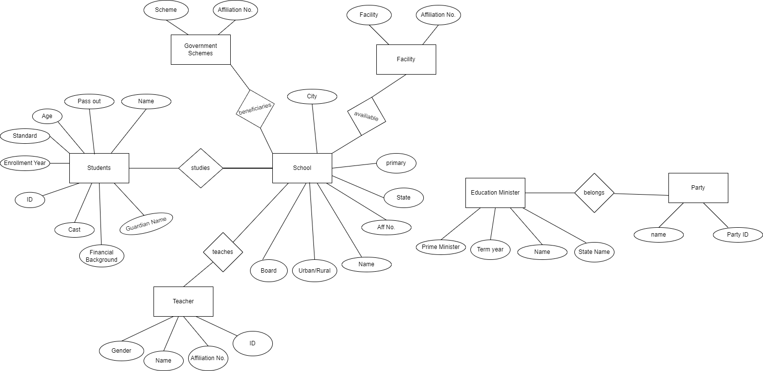

3.2 **Version 2**

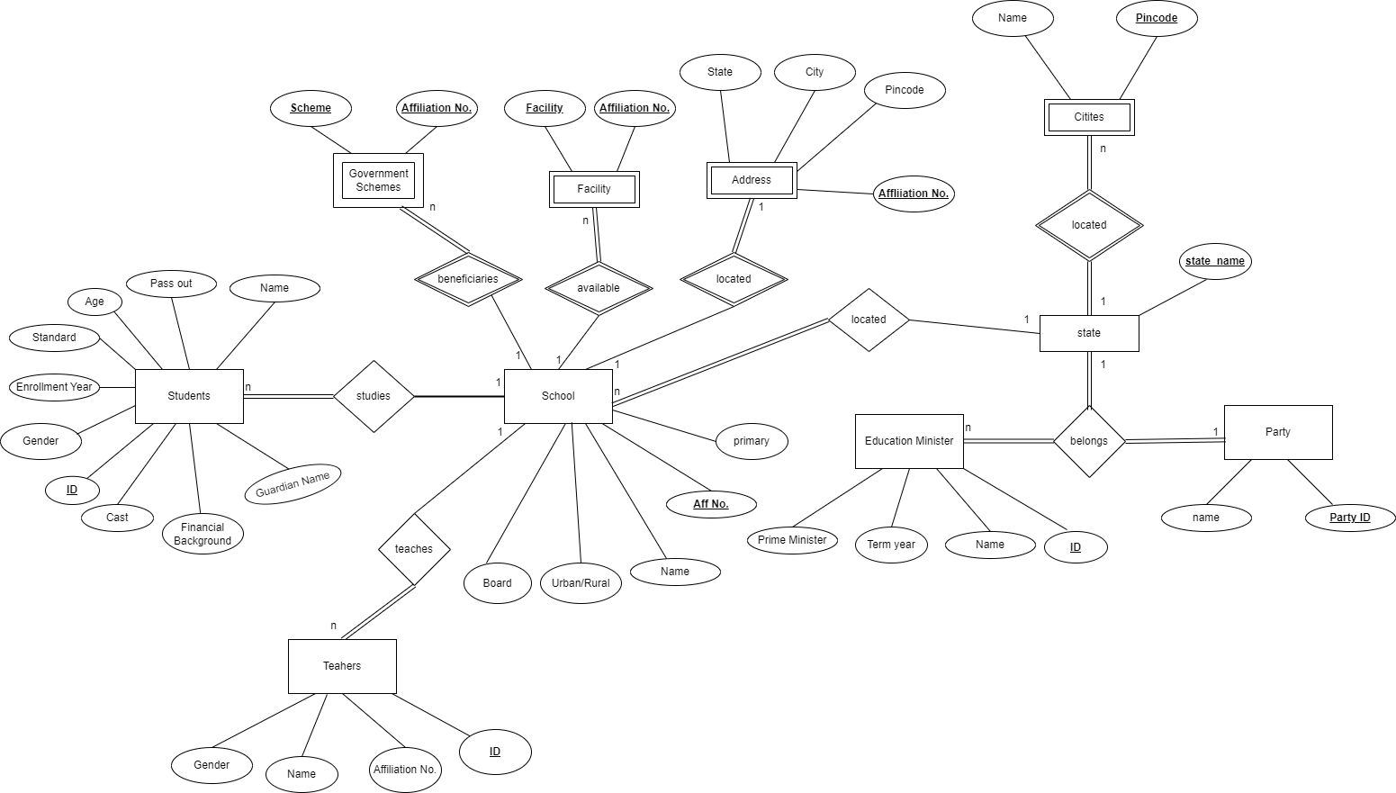

**FINALIZING E.R. DIAGRAM**

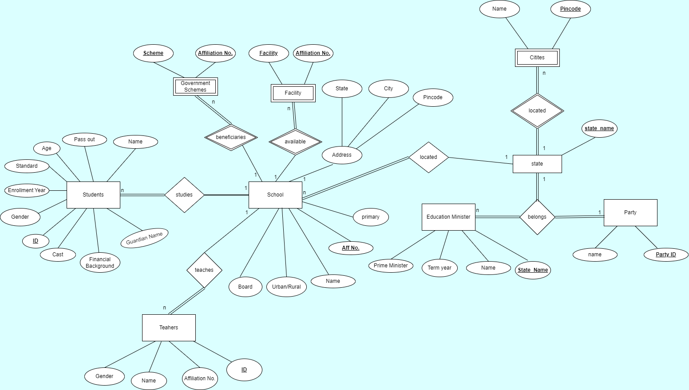

**FINAL NORMALIZATION**

**RELATIONAL MODEL WITH NORMALIZATION**

Below Relational Foreign Key and Primary Key Notation are FK and PK, respectively.

**Table 1:**

**All_schools(Affiliation_no, school_name, region, board, is_primary, state_name, city ,pincode)**

**Primary Key:** “Affiliation_no”

**Foreign_key**: “state_name” references “education_minister” table (updated)

Cardinality is Many to One between “all_schools” and “State” respectively, so taking state_name as foreign key.

**Functional Dependencies:**

Affiliation_no -> school_name,region,board,is_primary,pincode

pincode-> city,state_name

**Candidate Key** = {Affiliation_no}

**Prime Attribute:** {Affiliation_no}

**Test for 1NF**

All attributes are single valued so the table is in 1NF form.

**Test for 2NF**

The table is in 2NF when there are no partial dependencies.

Here there are no partial dependencies so the table is in 2NF.

**Test for 3NF**

The table is in 3NF when there are no transitive dependencies.

Here the dependency pincode-> city,state_name have transitive dependency so we will decompose the table into the following:

**All_schools(Affiliation_no, school_name, region, board, is_primary, pincode)**

**list_of_all_cities(pincode, state_name, city_name) *included below**

This separation also helps to prevent insertion anomaly, suppose we want to find the city in which there is no school, so we can analyze using list_of_all_cities_table.

This will also helps to remove deletion anomaly because previously if we want to add any city then there should be a school in that city but now we will not encounter this problem.

This will also helps to remove updation anomaly because if any city or state name is changed then this is prevent updation in multiple tuple of All_school table this will prevent update anomaly.

**Test for BCNF:**

The table is in BCNF if for every functional dependency x -> y the x should be a superkey.

Both the tables are in BCNF.

**Table 2:**

**Student(student_ID, name, age,gender, standard, enrollment_year, cast, financial_background, gaurdian_name, pass_out, Affiliation_no)**

**Primary key** is “student_ID”.

**Foreign** **Key** is “Affiliation_No.” referenced from “All_schools” relation.

Cardinality is Many to One between “students” and “all_school” respectively, so taking affliliation_no as a foreign key referenced from all_schools table.

**Functional Dependencies:**

student_ID -> name, age,gender, standard, enrollment_year, cast, financial_background, gaurdian_name, pass_out, Affiliation_no

**Candidate Key** = {student_id}

**Test for 1NF**

All attributes are single valued so the table is in 1NF form.

**Test for 2NF**

The table is in 2NF when there are no partial dependencies.

Here there are no partial dependencies so the table is in 2NF.

**Test for 3NF**

The table is in 3NF when there are no transitive dependencies.

Here there are no transitive dependencies.

Hence the table is in 3NF.

**Test for BCNF:**

The table is in BCNF if for every functional dependency x -> y the x should be a superkey.

The table is in BCNF.

**Table 3:**

**Teacher(name, Gender, Teacher_Id, affiliation_no)**

**Primary Key:** “Teacher_ID”

**Foreign Key:** “affliation_no” referenced from “ all_schools” relation.

Cardinality is Many to One between “Teacher” and "all_schools,” respectively, so taking affiliation_no as a foreign key referenced from “all_school” table.

**Functional Dependencies:**

Teacher_Id -> name, Gender, affiliation_no

**Candidate Key** = {Teacher_id}

**Test for 1NF**

All attributes are single valued so the table is in 1NF form.

**Test for 2NF**

The table is in 2NF when there are no partial dependencies.

Here there are no partial dependencies so the table is in 2NF.

**Test for 3NF**

The table is in 3NF when there are no transitive dependencies.

Here there are no transitive dependencies.

Hence the table is in 3NF.

**Test for BCNF:**

The table is in BCNF if for every functional dependency x -> y the x should be a superkey.

The table is in BCNF.

**Table 4:**

**Government_schemes(scheme_name, affiliation_no)**

**Requirement:** Is a Weak entity and needs a separate table

**Primary Key:** (scheme_name ,Affiliation_no) combined

**Foreign Key:** affiliation_no referenced from “ all_schools” relation.

Cardinality is Many to One between “Government_schemes” and "all_schools” respectively.

**Functional Dependencies:** It is an all key relationship therefore the table is already in BCNF.

**Candidate Key** = {scheme_name, affiliation_no}

**Table 5:**

**Facilities(facility_name, affiliation_no)**

**Requirement:** Is a Weak entity, and needs a separate table

**Primary Key:** (facility_name, affiliation_no) combined

**Foreign Key:**  “affiliation_no” referenced from “ all_schools” relation.

Cardinality is Many to One between “Facilities” and "all_schools” respectively.

**Functional Dependencies:** It is an all key relationship therefore the table is already in BCNF.

**Candidate Key** = {facility_name, affiliation_no}

**Table 6:**

**list_of_all_state(state_name)**

**Requirement:** Prevent Insertion errors and anomalies and further optimize the CRUD operations of the Database.

**Primary Key:** “state_name”

As the attribute is already in “list_of_all_cities”, this is simply repeating the information in two different tables.

Hence, we are removing the relation

**\*REMOVED**

**Table 7:**

**list_of_all_cities(pincode, state_name, city_name)**

**Requirement:** Prevent Insertion errors and anomalies and further optimize the CRED operations of the Database.

**Primary Key:** pincode

**Foreign Key:**“state_name” references “education_minister” table (updated).

Cardinality is Many to One between “list_of_all_cities” and "list_of_all_state” respectively, so taking state_name as a foreign key referenced from list_of_all_states table.

**Functional Dependencies:** It is an all key relationship therefore the table is already in BCNF.

**Candidate Key** = {pincode}

**Test for 1NF**

All attributes are single valued so the table is in 1NF form.

**Test for 2NF**

The table is in 2NF when there are no partial dependencies.

Here there are no partial dependencies so the table is in 2NF.

**Test for 3NF**

The table is in 3NF when there are no transitive dependencies.

Here there are no transitive dependencies.

Hence the table is in 3NF.

**Test for BCNF:**

The table is in BCNF if for every functional dependency x -> y the x should be a superkey.

The table is in BCNF.

**Table 8:**

**Education_minister(Minister_ID,name, term_year, prime_minister, party_id, state_name)**

**Primary Key:** “state_name” (updated)

**Foreign Key:** “party_id” referenced from “party” relation.

Cardinality is many to one between education_minister and state and cardinality is also many to one between education_minister and party, so taking state_name and party_id as a foreign key referenced from list_of_all_states and party table.

**Functional Dependencies**

state_name -> Minister_ID,name, term_year, prime_minister, party_id, state_name

**Candidate Key** = {state_name}

**Test for 1NF**

All attributes are single valued so the table is in 1NF form.

**Test for 2NF**

The table is in 2NF when there are no partial dependencies.

Here there are no partial dependencies so the table is in 2NF.

**Test for 3NF**

The table is in 3NF when there are no transitive dependencies.

Here there are no transitive dependencies.

Hence the table is in 3NF.

**Test for BCNF:**

The table is in BCNF if for every functional dependency x -> y the x should be a superkey.

The table is in BCNF.

**Table 9:**

**Party(party_id, party_name)**

**Primary Key:** “party_id”

**Functional Dependencies**

Party_id -> party_name

**Candidate Key** = {party_id}

**Test for 1NF**

All attributes are single valued so the table is in 1NF form.

**Test for 2NF**

The table is in 2NF when there are no partial dependencies.

Here there are no partial dependencies so the table is in 2NF.

**Test for 3NF**

The table is in 3NF when there are no transitive dependencies.

Here there are no transitive dependencies.

Hence the table is in 3NF.

**Test for BCNF:**

The table is in BCNF if for every functional dependency x -> y the x should be a superkey.

The table is in BCNF.

**NOTE(after update):-**  Total Tables are reduced to 8, Redundancy was reduced in TABLE 1.

All tables are normalized till BCNF.

3 **DDL SCRIPT**

[Link to SQL file](https://drive.google.com/file/d/1MJoCB36QtxZ8CAOZDrqqBRMrqaanEPRb/view?usp=share_link)

-- Creating the table for list_of_all_states

-- CREATE TABLE IF NOT EXISTS education_minister.list_of_all_state

-- (

-- state_name character varying COLLATE pg_catalog."default" NOT NULL,

-- CONSTRAINT list_of_all_state_pkey PRIMARY KEY (state_name)

-- )

--removing this table after normalization

-- Creating the table for party

create table if not exists education_minister.party(

party_id bigint primary key,

party_name character varying not null

)

-- Creating the table for minister

create table if not exists education_minister.minister(

minister_id bigint unique,

name character varying not null,

term_year bigint not null,

prime_minister character varying not null,

party_id bigint not null,

state_name character varying not null,

primary key(state_name),

foreign key(party_id) references education_minister.party(party_id)

on delete set default on update cascade

)

-- Creating the table for list_of_all_cities

create table if not exists education_minister.list_of_all_cities(

pincode bigint primary key,

state_name character varying not null,

city_name character varying not null,

foreign key(state_name) references education_minister.minister(state_name) on delete set null

on update cascade

)

-- Creating the table for all_schools

create table if not exists education_minister.all_schools(

affiliation_no bigint primary key,

school_name character varying not null,

region character varying,

board character varying,

is_primary BOOLEAN,

pincode bigint not null,

foreign key(pincode) references education_minister.list_of_all_cities(pincode)

on delete set default

)

-- Creating the table for government_schemes

create table if not exists education_minister.government_schemes(

scheme_name character varying,

affiliation_no bigint,

primary key(scheme_name,affiliation_no),

foreign key(affiliation_no) references education_minister.all_schools(affiliation_no)

on delete cascade

on update cascade

)

-- Creating the table for facilities

create table if not exists education_minister.facilities(

facility_name character varying,

affiliation_no bigint,

primary key(facility_name,affiliation_no),

foreign key(affiliation_no) references education_minister.all_schools(affiliation_no)

on delete cascade

on update cascade

)

-- Creating the table for teacher

create table if not exists education_minister.teacher(

teacher_id bigint primary key,

name character varying not null,

gender character varying not null,

affiliation_no bigint not null,

foreign key(affiliation_no) references education_minister.all_schools(affiliation_no)

on delete set default on update cascade

)

-- creating student table

CREATE TABLE IF NOT EXISTS education_minister.student

(

student_id bigint NOT NULL,

name character varying not null COLLATE pg_catalog."default",

age bigint,

gender character varying COLLATE pg_catalog."default",

standard integer,

enrollment_year bigint,

cast_name character varying COLLATE pg_catalog."default",

financial_background character varying COLLATE pg_catalog."default",

gaurdian_name character varying COLLATE pg_catalog."default",

pass_out boolean DEFAULT false,

affiliation_no bigint,

CONSTRAINT student_pkey PRIMARY KEY (student_id),

CONSTRAINT student_affiliation_no_fkey FOREIGN KEY (affiliation_no)

REFERENCES education_minister.all_schools (affiliation_no) MATCH SIMPLE

ON UPDATE cascade

ON DELETE set default

)

**TRIGGERS AND THEIR FUNCTION**

-- Trigger and Function for inserting in cities

-- CREATE OR REPLACE FUNCTION education_minister.insert_cities()

-- returns trigger

-- language 'plpgsql'

-- as

-- $BODY$

-- DECLARE

-- BEGIN

-- if(new.pincode is null or new.state_name = 'null')

-- THEN return old;

-- else return new;

-- end if;

-- END

-- $BODY$

-- --

-- create or replace trigger insert_in_cities

-- before insert on education_minister.list_of_all_cities

-- for each row

-- execute function education_minister.insert_cities();

--

-- Trigger and Function for inserting in government schemes

-- CREATE OR REPLACE FUNCTION education_minister.insert_schemes()

-- returns trigger

-- language 'plpgsql'

-- as

-- $BODY$

-- DECLARE

-- BEGIN

-- if(new.affiliation_no is null or new.scheme_name is null )

-- THEN return old;

-- else return new;

-- end if;

-- END

-- $BODY$

-- create or replace trigger insert_in_schemes

-- before insert on education_minister.government_schemes

-- for each row

-- execute function education_minister.insert_schemes();

-- Trigger and Functions for inserting in Facilities

-- CREATE OR REPLACE FUNCTION education_minister.insert_facility()

-- returns trigger

-- language 'plpgsql'

-- as

-- $BODY$

-- DECLARE

-- BEGIN

-- if(new.affiliation_no is null or new.facility_name is null )

-- THEN return old;

-- else return new;

-- end if;

-- END

-- $BODY$

-- create or replace trigger insert_in_facility

-- before insert on education_minister.facilities

-- for each row

-- execute function education_minister.insert_facility();

-- --

-- CREATE OR REPLACE FUNCTION education_minister.insert_teacher()

-- returns trigger

-- language 'plpgsql'

-- as

-- $BODY$

-- DECLARE

-- BEGIN

-- if(new.affiliation_no is null or new.teacher_id is null )

-- THEN return old;

-- else return new;

-- end if;

-- END

-- $BODY$

-- create or replace trigger insert_in_teacher

-- before insert on education_minister.teacher

-- for each row

-- execute function education_minister.insert_teacher();

--

CREATE OR REPLACE FUNCTION education_minister.insert_student()

returns trigger

language 'plpgsql'

as

$BODY$

DECLARE

BEGIN

if(new.affiliation_no is null or new.student_id is null or new.name is null )

THEN return old;

else return new;

end if;

END

$BODY$

create or replace trigger insert_in_student

before insert on education_minister.student

for each row

execute function education_minister.insert_student();

**SQL QUERIES**

**SQL QUERIES**

1. Find the name of students which are male

**SQL:**

select name

from education_minister.student

where gender='Male'

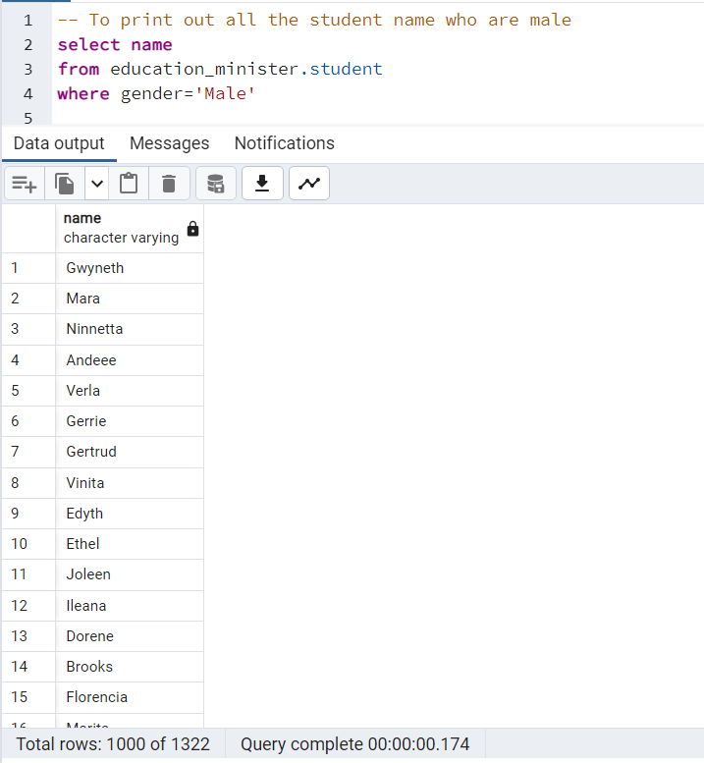

1. Get the details of all the teachers who are female.

**SQL:**

select *

from education_minister.teacher

where gender='Female'

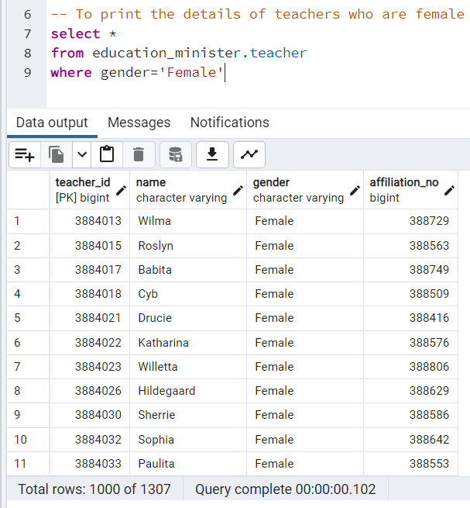

1. To get the details of the education minister of Gujarat.

**SQL:**

select *

from education_minister.minister

where state_name='gujarat'

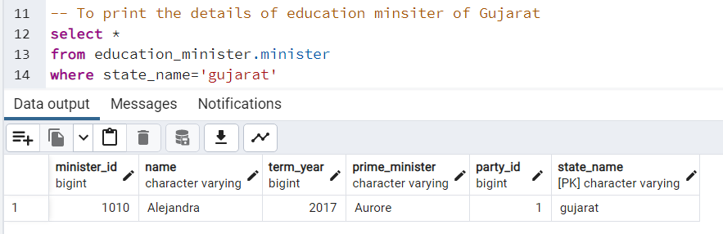

1. Find the number of all education minister belongs to party with party ID in descending order of count.

**SQL:**

select party_id,count(name)

from education_minister.minister

group by party_id

order by count(name) desc

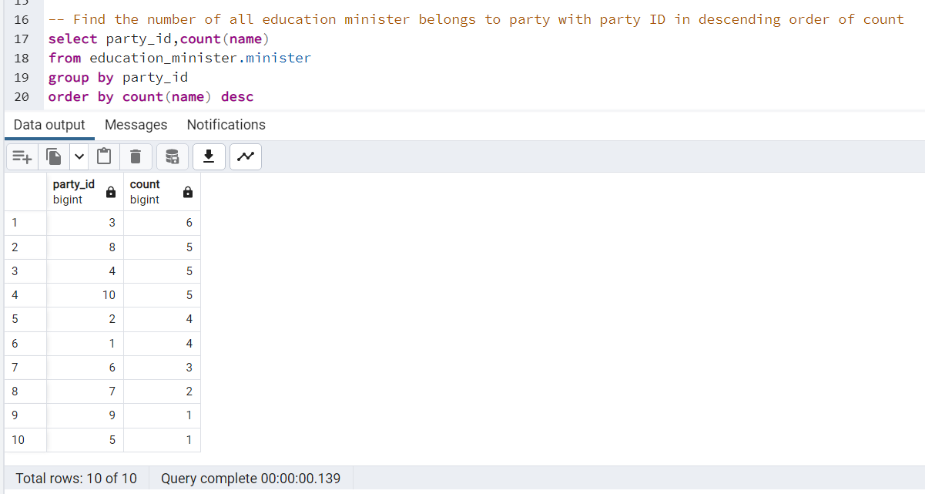

1. Find the details of party whose party_id is 1.

**SQL:**

select *

from education_minister.party

where party_id = 1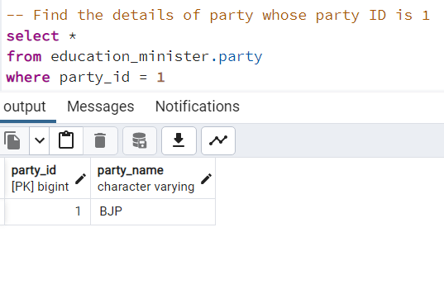

1. To find the number of government schemes in a particular school with affiliation number in descending order

**SQL:**

select affiliation_no, count(scheme_name)

from education_minister.government_schemes

group by affiliation_no

order by count(scheme_name) desc

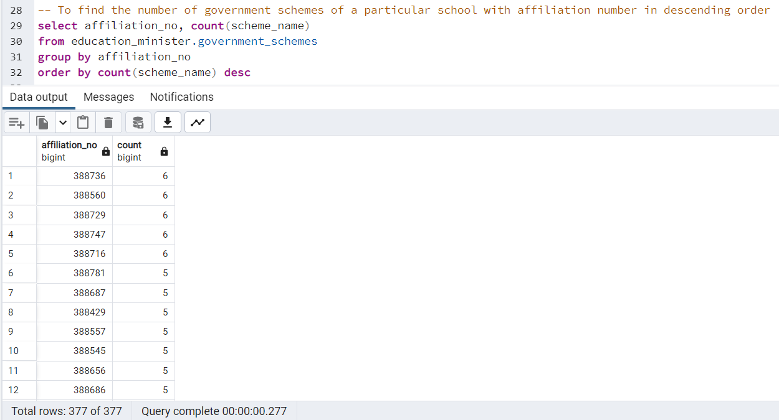

1. To find the number of facilities of a particular school with affiliation number in ascending order

**SQL:**

select affiliation_no, count(facility_name)

from education_minister.facilities

group by affiliation_no

order by count(facility_name) asc

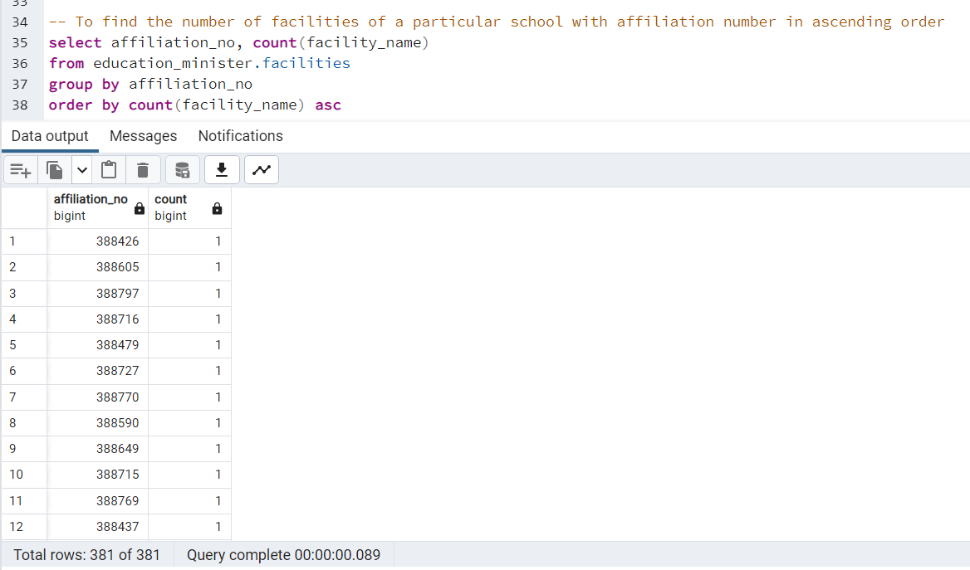

1. To find the affiliation number of schools which have library facility

**SQL:**

select affiliation_no

from education_minister.facilities

where facility_name = 'Library'

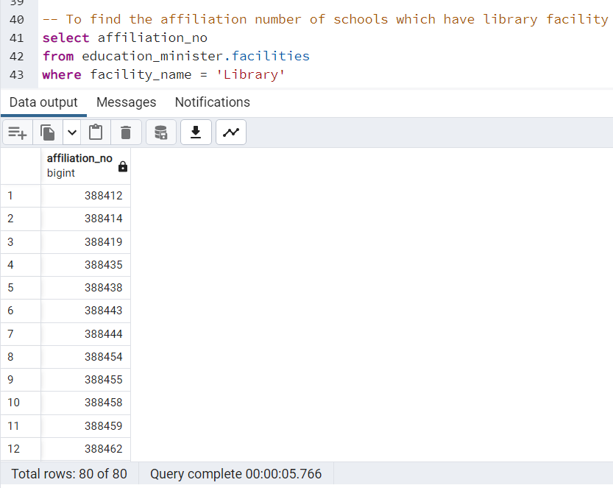

1. To find the details of a particular school having affiliation_no as 388412.

**SQL:**

select *

from education_minister.all_schools

where affiliation_no=388412

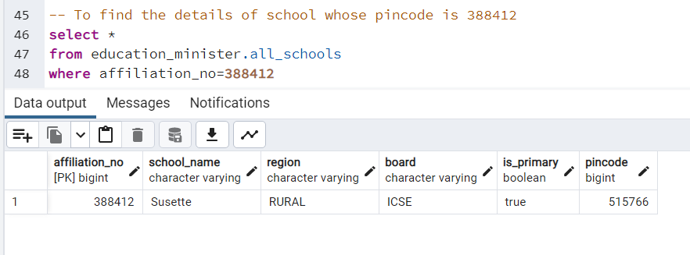

1. To find the number of schools in urban and rural region

**SQL:**

select region,count(affiliation_no)

from education_minister.all_schools

group by region

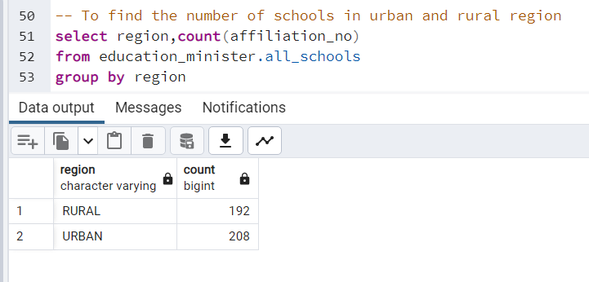

1. To find student name, student id affiliated with each school

**SQL:**

select s1.student_id,s1."name",s2.affiliation_no,s2.school_name

from education_minister.student as s1 join education_minister.all_schools as s2

on s1.affiliation_no = s2.affiliation_no

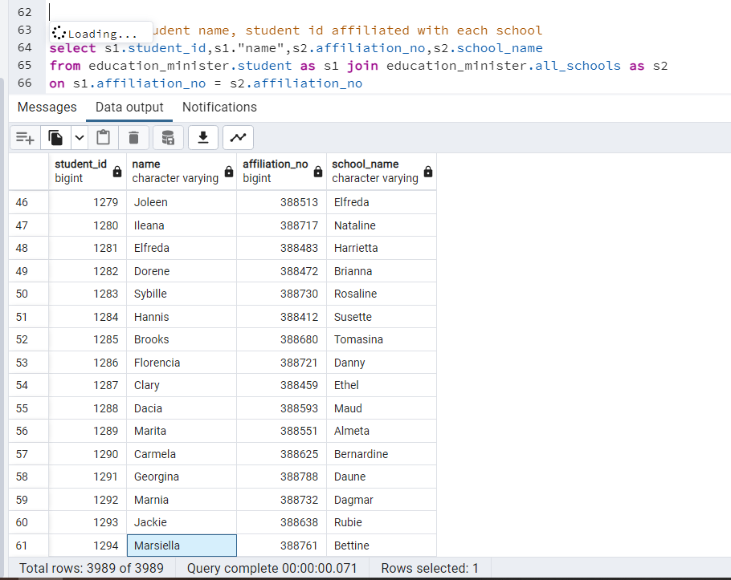

1. To find the number of schools in urban and rural region

**SQL:**

select region,count(affiliation_no)

from education_minister.all_schools

group by region

-- To find the No. of male, female and trans students in each school

create or replace view education_minister.male_std_count as

select s1.affiliation_no,count(s1.gender)

from education_minister.student as s1 join education_minister.all_schools as s2

on s2.affiliation_no = s1.affiliation_no

where s1.gender='Male'

group by s1.affiliation_no

alter table education_minister.male_std_count

rename column affiliation_no to school_id

alter table education_minister.male_std_count

rename column count to Male

--

create or replace view education_minister.female_std_count as

select s1.affiliation_no,count(s1.gender)

from education_minister.student as s1 join education_minister.all_schools as s2

on s2.affiliation_no = s1.affiliation_no

where s1.gender='Female'

group by s1.affiliation_no

alter table education_minister.female_std_count

rename column affiliation_no to school_id

alter table education_minister.female_std_count

rename column count to Female

--

create or replace view education_minister.trans_std_count as

select s1.affiliation_no,count(s1.gender)

from education_minister.student as s1 join education_minister.all_schools as s2

on s2.affiliation_no = s1.affiliation_no

where s1.gender='Trans'

group by s1.affiliation_no

alter table education_minister.trans_std_count

rename column affiliation_no to school_id

alter table education_minister.trans_std_count

rename column count to Trans

SELECT s4.school_id,s4.male,s4.female,s3.trans

from (select s1.school_id,s1.male,s2.female from education_minister.male_std_count as s1 join education_minister.female_std_count as s2 on s1.school_id=s2.school_id) as s4

join education_minister.trans_std_count as s3

on s4.school_id=s3.school_id

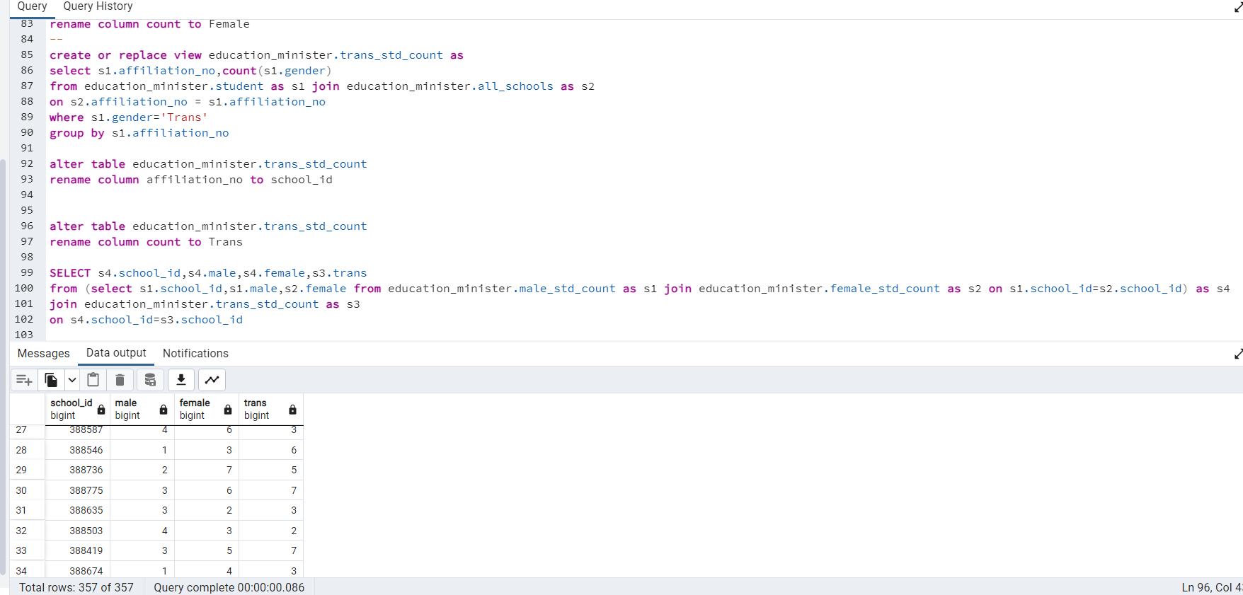

1. Count the number of facility in each school

**SQL:**

select s1.school_name,count(s2.facility_name) as facilities

from education_minister.all_schools as s1 join education_minister.facilities as s2

on s1.affiliation_no = s2.affiliation_no

group by s1.school_name

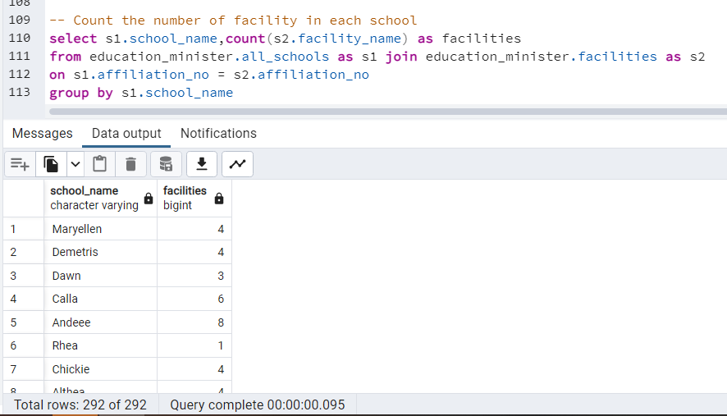

1. Count pass_out ratio in each school

**SQL:**

select t1.affiliation_no,(cast(((t1.Pass_out/t2.total_count)*100) as double precision)||'%')

from(

select s1.affiliation_no,cast(count(pass_out) as double PRECISION) as Pass_Out

from education_minister.all_schools as s1 join education_minister.student as s2

on s1.affiliation_no = s2.affiliation_no

where s2.pass_out=true

group by s1.affiliation_no

) as t1 join

(

select affiliation_no, cast(count(affiliation_no) as double precision) as total_count

from education_minister.student

group by affiliation_no

) as t2 on t1.affiliation_no = t2.affiliation_no

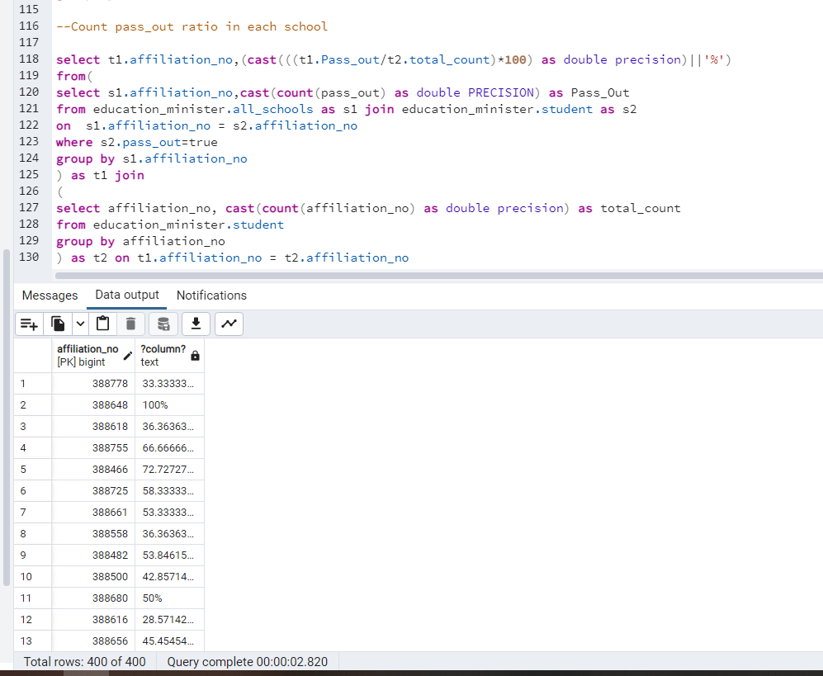

1. Show Education minister with it's respective party.

**SQL:**

SELECT s1.state_name,s1.minister_id,s1.name,s2.party_id,s2.party_name

from education_minister.minister as s1 join education_minister.party as s2

on s1.party_id = s2.party_id

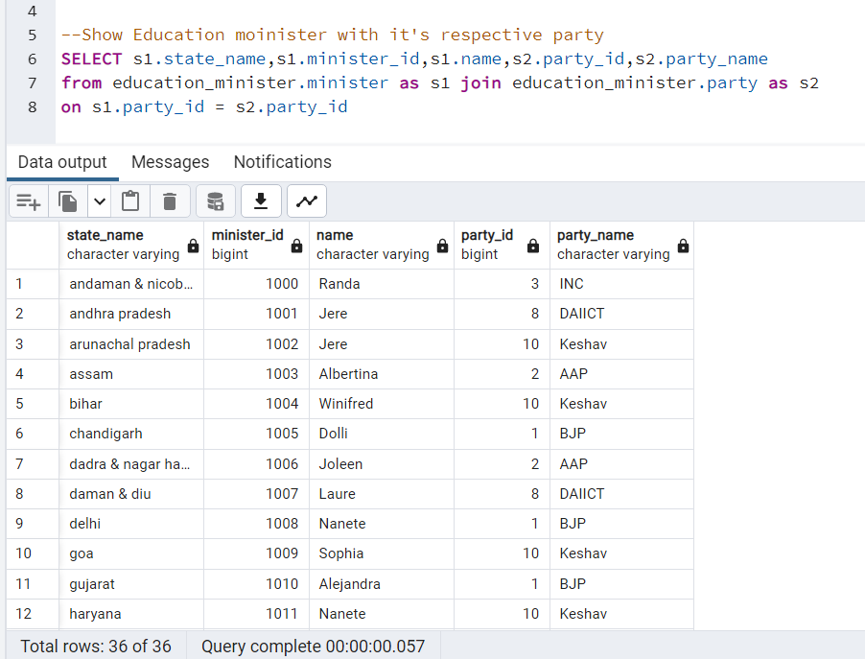

1. To count the number of teachers in each region.

**SQL:**

select s2.region,count(s1.affiliation_no)

from education_minister.teacher as s1 join education_minister.all_schools as s2

on s1.affiliation_no = s2.affiliation_no

group by s2.region

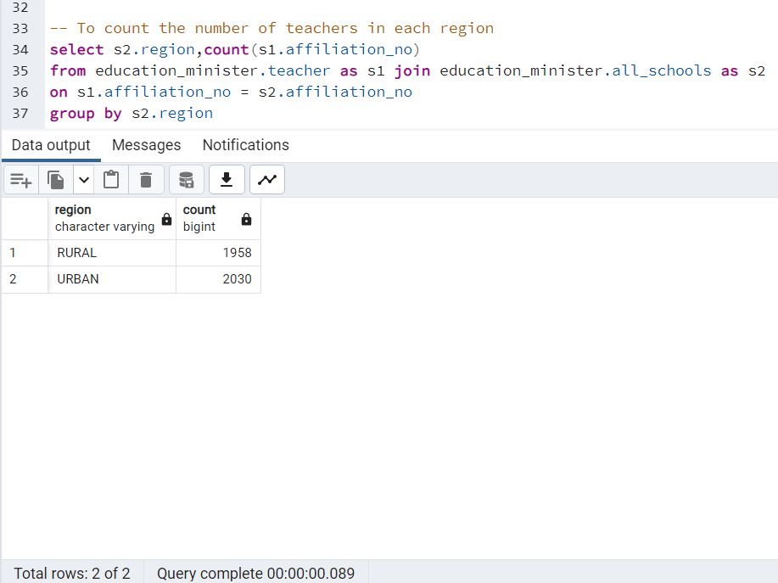

1. Find out how many schools are in each state in ascending order of the count of school.

**SQL:**

select s2.state_name,count(s1.affiliation_no)

from education_minister.all_schools as s1 join education_minister.list_of_all_cities as s2

on s2.pincode = s1.pincode

group by s2.state_name

order by count(s1.affiliation_no)

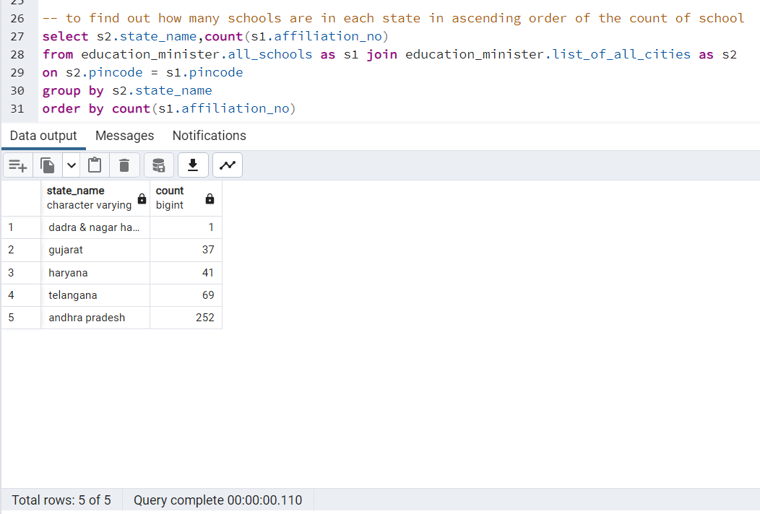

1. To get the count of how many schools are there in urban and rural region in each city

**SQL:**

select t1.state_name as State,t1.rural,t2.urban

from(

select s2.state_name,count(s1.region) as rural

from education_minister.all_schools as s1 full join education_minister.list_of_all_cities as s2

on s2.pincode = s1.pincode

where s1.region='RURAL'

group by s2.state_name)

as t1 full join (

select s2.state_name,count(s1.region) as urban

from education_minister.all_schools as s1 full join education_minister.list_of_all_cities as s2

on s2.pincode = s1.pincode

where s1.region='URBAN'

group by s2.state_name

) as t2

on t1.state_name=t2.state_name

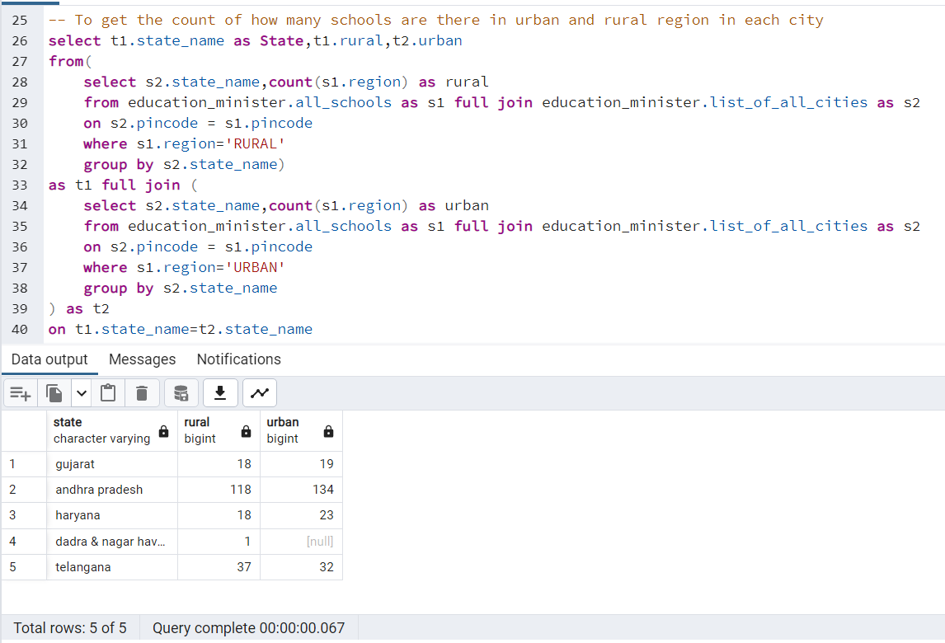

1. To get the ratio of schools in urban vs rural region in each state

**SQL:**

CREATE OR REPLACE FUNCTION education_minister.rural_to_urban_ratio(rural double precision,urban double precision)

returns double precision

language 'plpgsql'

as

$BODY$

DECLARE ratio double precision;

BEGIN

ratio = rural/urban;

return ratio;

END

$BODY$

select t1.state_name as State,education_minister.rural_to_urban_ratio(cast(t1.rural as double precision),cast(t2.urban as double precision))

from(

select s2.state_name,count(s1.region) as rural

from education_minister.all_schools as s1 full join education_minister.list_of_all_cities as s2

on s2.pincode = s1.pincode

where s1.region='RURAL'

group by s2.state_name)

as t1 full join (

select s2.state_name,count(s1.region) as urban

from education_minister.all_schools as s1 full join education_minister.list_of_all_cities as s2

on s2.pincode = s1.pincode

where s1.region='URBAN'

group by s2.state_name

) as t2

on t1.state_name=t2.state_name

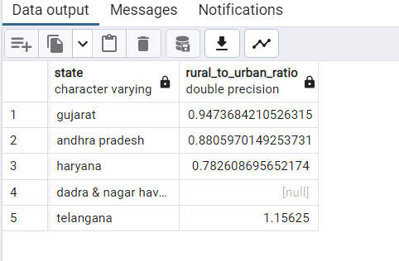

1. To count the number of teachers in each state.

**SQL:**

select t2.state_name,count(t1.teacher_id)

from(

select s2.pincode,s1.teacher_id

from education_minister.teacher as s1 join education_minister.all_schools as s2

on s1.affiliation_no = s2.affiliation_no

) as t1 right join education_minister.list_of_all_cities as t2

on t1.pincode = t2.pincode

group by t2.state_name

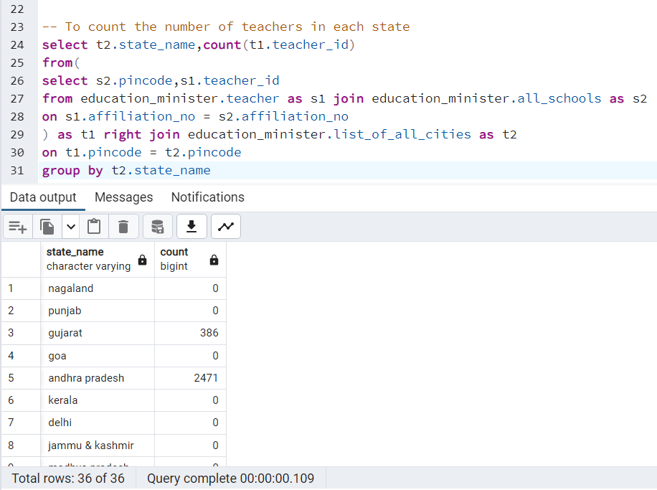

**BACKEND CODE**

**The project’s backend is been coded in Django.**

**Connects frontend with backend (Using Django):**

**DATABASES = {**

**'default': {**

**'ENGINE': 'django.db.backends.postgresql',**

**'NAME': 'education_minister',**

**'USER':'postgres',**

**'PASSWORD':'admin',**

**'HOST':'localhost',**

**'PORT':'5432'**

**}**

**}**

**AUTH_PASSWORD_VALIDATORS = [**

**{**

**'NAME': 'django.contrib.auth.password_validation.UserAttributeSimilarityValidator',**

**},**

**{**

**'NAME': 'django.contrib.auth.password_validation.MinimumLengthValidator',**

**},**

**{**

**'NAME': 'django.contrib.auth.password_validation.CommonPasswordValidator',**

**},**

**{**

**'NAME': 'django.contrib.auth.password_validation.NumericPasswordValidator',**

**},**

**]**

**Code for setting up URL:**

**from django.contrib import admin**

**from django.urls import path**

**from . import views**

**urlpatterns = [**

**path('admin/', admin.site.urls),**

**path('',views.main_page,name="main_page"),**

**path('party',views.Party,name="Party"),**

**path('insert_party',views.insert_party,name="insert_party"),**

**path('delete_party/<int:id>',views.delete_party,name="delete_party"),**

**path('minister',views.Minister,name="Minister"),**

**path('school',views.School,name = "School"),**

**path('Student',views.Student,name = "Student"),**

**path('delete_student/<int:id>',views.delete_student,name="delete_student"),**

**path('edit_student/<int:id>',views.edit_student,name="edit_student"),**

**path('insert_student',views.insert_student,name = "insert_student"),**

**]**

**Code for setting up the modules used for frontend:**

**from django.db import models**

**class party(models.Model):**

**party_id = models.BigIntegerField(primary_key=True)**

**party_name = models.CharField(max_length=100)**

**class Meta:**

**db_table = "party"**

**class minister(models.Model):**

**minister_id = models.BigIntegerField()**

**name = models.CharField(max_length=100)**

**term_year = models.BigIntegerField()**

**prime_minister = models.CharField(max_length=100)**

**# party_id = models.ForeignKey(party,on_delete=models.CASCADE)**

**party_id = models.BigIntegerField()**

**state_name = models.CharField(primary_key=True,max_length=100)**

**class Meta:**

**db_table = "minister"**

**class list_of_cities(models.Model):**

**pincode = models.BigIntegerField(primary_key=True)**

**state_name = models.CharField(max_length=100)**

**# state_name = models.ForeignKey(minister,on_delete=models.CASCADE)**

**city_name = models.CharField(max_length=100)**

**class Meta:**

**db_table = "list_of_cities"**

**class all_schools(models.Model):**

**affiliation_no = models.BigIntegerField(primary_key=True)**

**school_name = models.CharField(max_length=100)**

**region = models.CharField(max_length=100)**

**board = models.CharField(max_length=10)**

**is_primary = models.BooleanField()**

**# pincode = models.ForeignKey(list_of_cities)**

**pincode = models.BigIntegerField()**

**class Meta:**

**db_table = "all_schools"**

**class student(models.Model):**

**student_id = models.BigIntegerField(primary_key=True)**

**name = models.CharField(max_length=100)**

**age = models.BigIntegerField()**

**gender = models.CharField(max_length=10)**

**standard = models.BigIntegerField()**

**enrollment_year = models.BigIntegerField()**

**cast_name = models.CharField(max_length=100)**

**financial_background = models.CharField(max_length=100)**

**gaurdian_name = models.CharField(max_length=100)**

**pass_out = models.BooleanField()**

**# affiliation_no = models.ForeignKey(all_schools)**

**affiliation_no = models.BigIntegerField()**

**class Meta:**

**db_table = "student"**

**Code for fetching, editing and deleting in the database:**

**def main_page(request):**

**return render(request,"index.html")**

**def Party(request):**

**if request.method == "GET":**

**p = party.objects.all()**

**return render(request,"view_party.html",{"party":p})**

**def insert_party(request):**

**if request.method == "POST":**

**if request.POST.get("party_id") and request.POST.get("party_name"):**

**new_obj = party(party_id=request.POST.get("party_id"),party_name=request.POST.get("party_name"))**

**new_obj.save()**

**messages.success(request,"The party with party ID "+request.POST.get("party_id")+" is saved successfully")**

**return render(request,"insert_party.html",{"party":party.objects.all()})**

**else:**

**messages.error(request,"Invalid Inputs")**

**return render(request,'insert_party.html')**

**else:**

**return render(request,'insert_party.html')**

**def delete_party(request,id):**

**d = party.objects.get(party_id=id)**

**d.delete()**

**messages.success(request,"The party with party ID "+id+" is deleted Succesfully")**

**return render(request,"view_party.html",{"party":party.objects.all()})**

**def Minister(request):**

**d = minister.objects.all()**

**return render(request,"view_minister.html",{"minister":d})**

**def School(request):**

**d = all_schools.objects.all()**

**return render(request,"school_view.html",{"school":d})**

**def Student(request):**

**d = student.objects.all()**

**return render(request,"student_view.html",{"student":d})**

**def delete_student(request,id):**

**d = student.objects.get(student_id=id)**

**d.delete()**

**messages.success(request,'The student with student id '+str(id)+" is deleted Successfully")**

**return render(request,"student_view.html",{"student":student.objects.all()})**

**def edit_student(request,id):**

**if request.method == "POST":**

**updatstudent = student.objects.get(student_id=id)**

**form =Studentforms(request.POST,instance=updatstudent)**

**if form.is_valid():**

**form.save()**

**messages.success(request,'Record Updated Successfully')**

**return render(request,"edit_student_page.html",{'student':student.objects.get(student_id=id)})**

**else:**

**messages.error(request,"Unable to edit the record")**

**return render(request,"edit_student_page.html",{"student":student.objects.get(student_id = id)})**

**else:**

**return render(request,"edit_student_page.html",{"student":student.objects.get(student_id=id)})**

**def insert_student(request):**

**if request.method == "POST":**

**new_student = student()**

**new_student.student_id = request.POST.get("student_id")**

**new_student.name = request.POST.get("name")**

**new_student.age = request.POST.get("age")**

**new_student.gender = request.POST.get('gender')**

**new_student.standard = request.POST.get("standard")**

**new_student.enrollment_year = request.POST.get('enrollment_year')**

**new_student.cast_name = request.POST.get("cast_name")**

**new_student.financial_background = request.POST.get('financial_background')**

**new_student.gaurdian_name = request.POST.get("gaurdian_name")**

**new_student.pass_out = request.POST.get("pass_out")**

**new_student.affiliation_no = request.POST.get("affiliation_no")**

**new_student.save()**

**messages.success(request,"Student with studentID "+request.POST.get("student_id")+" is added successfully")**

**return render(request,"insert_student.html")**

**else:**

**return render(request,"insert_student.html")**

**FRONTEND IMAGES**

**Home Page:**

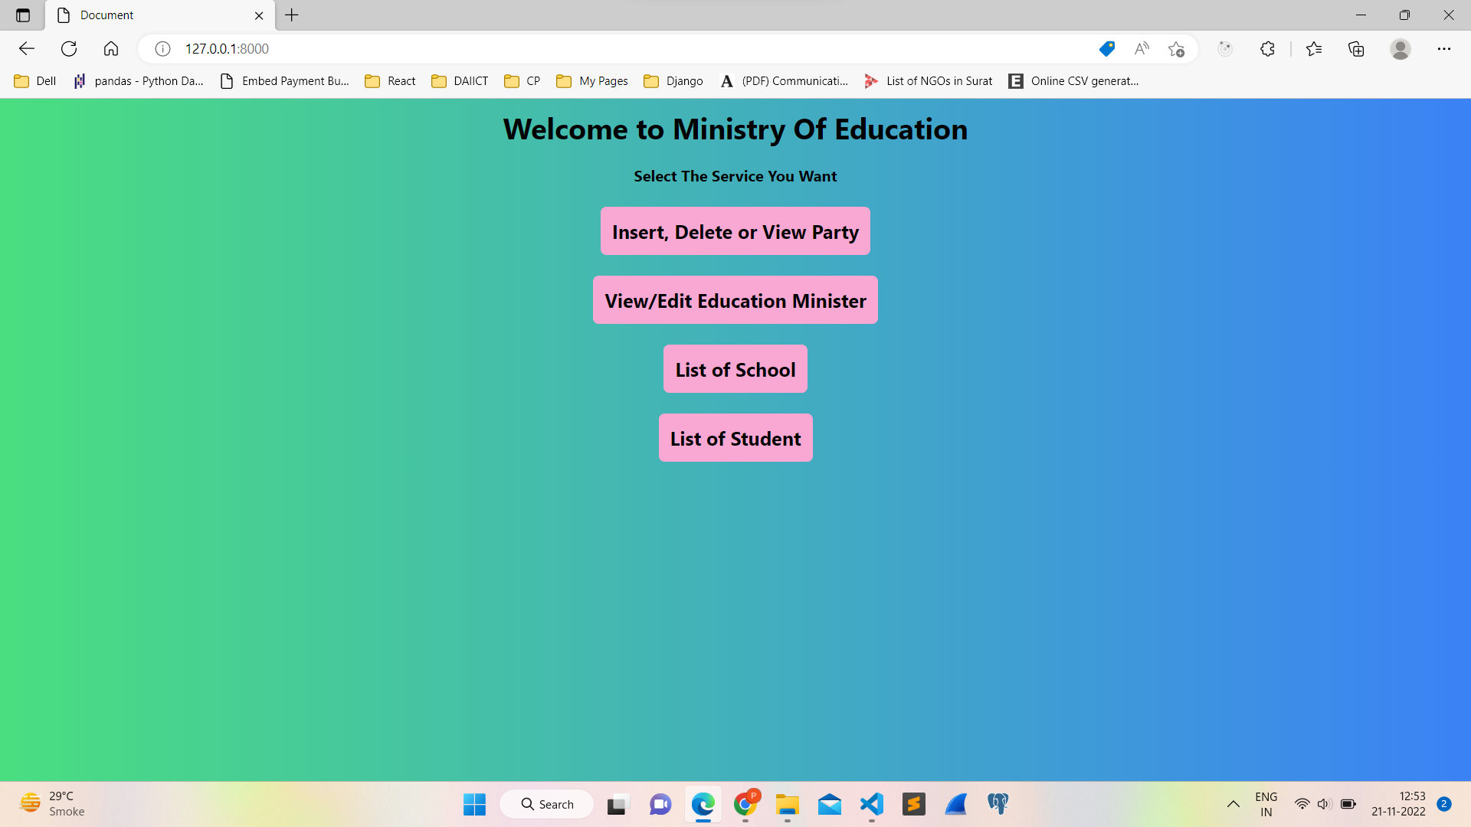

**Party Page:**

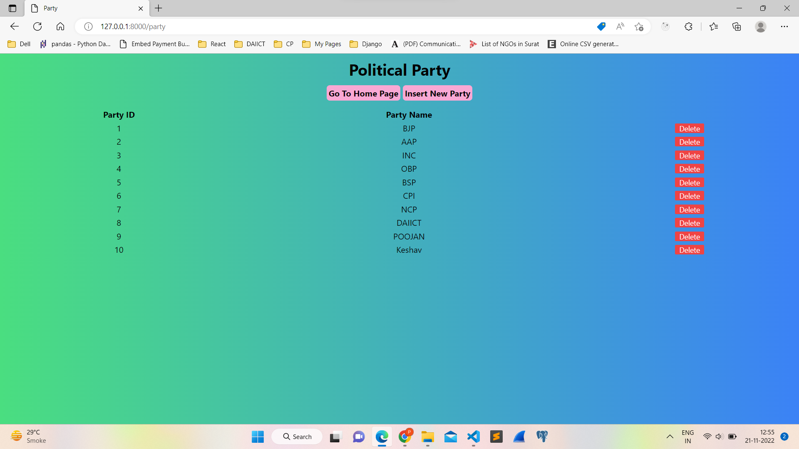

Insert A new party:

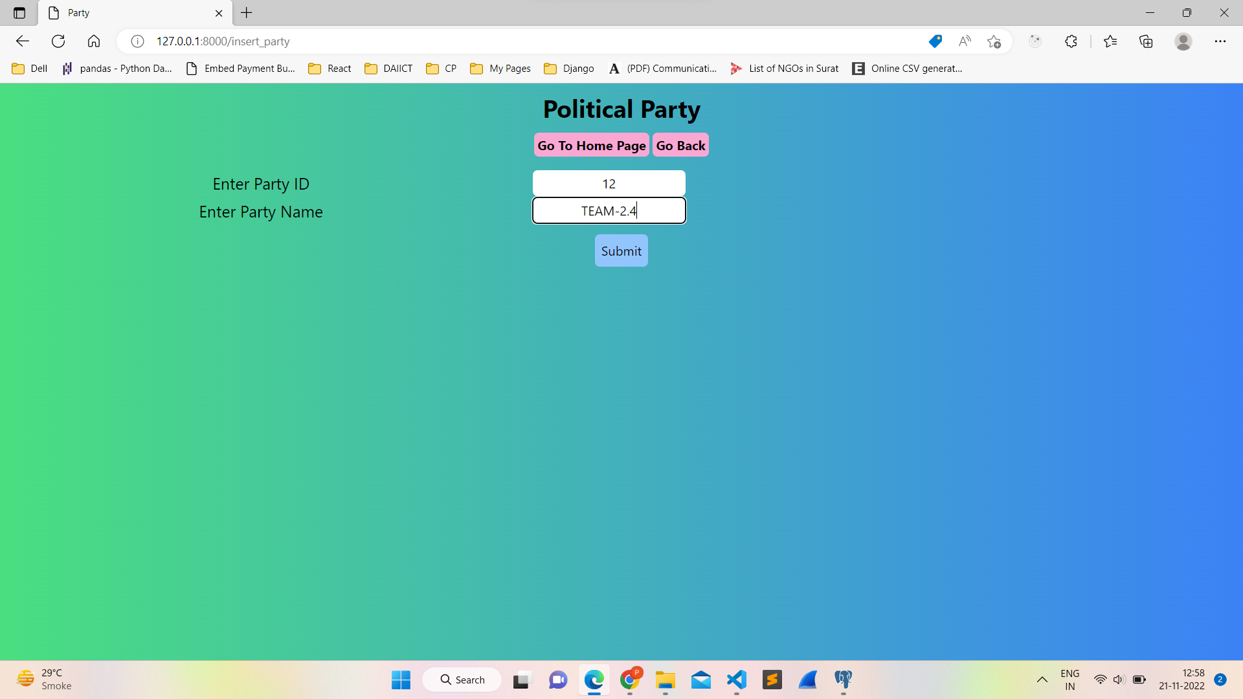

New view of party database:

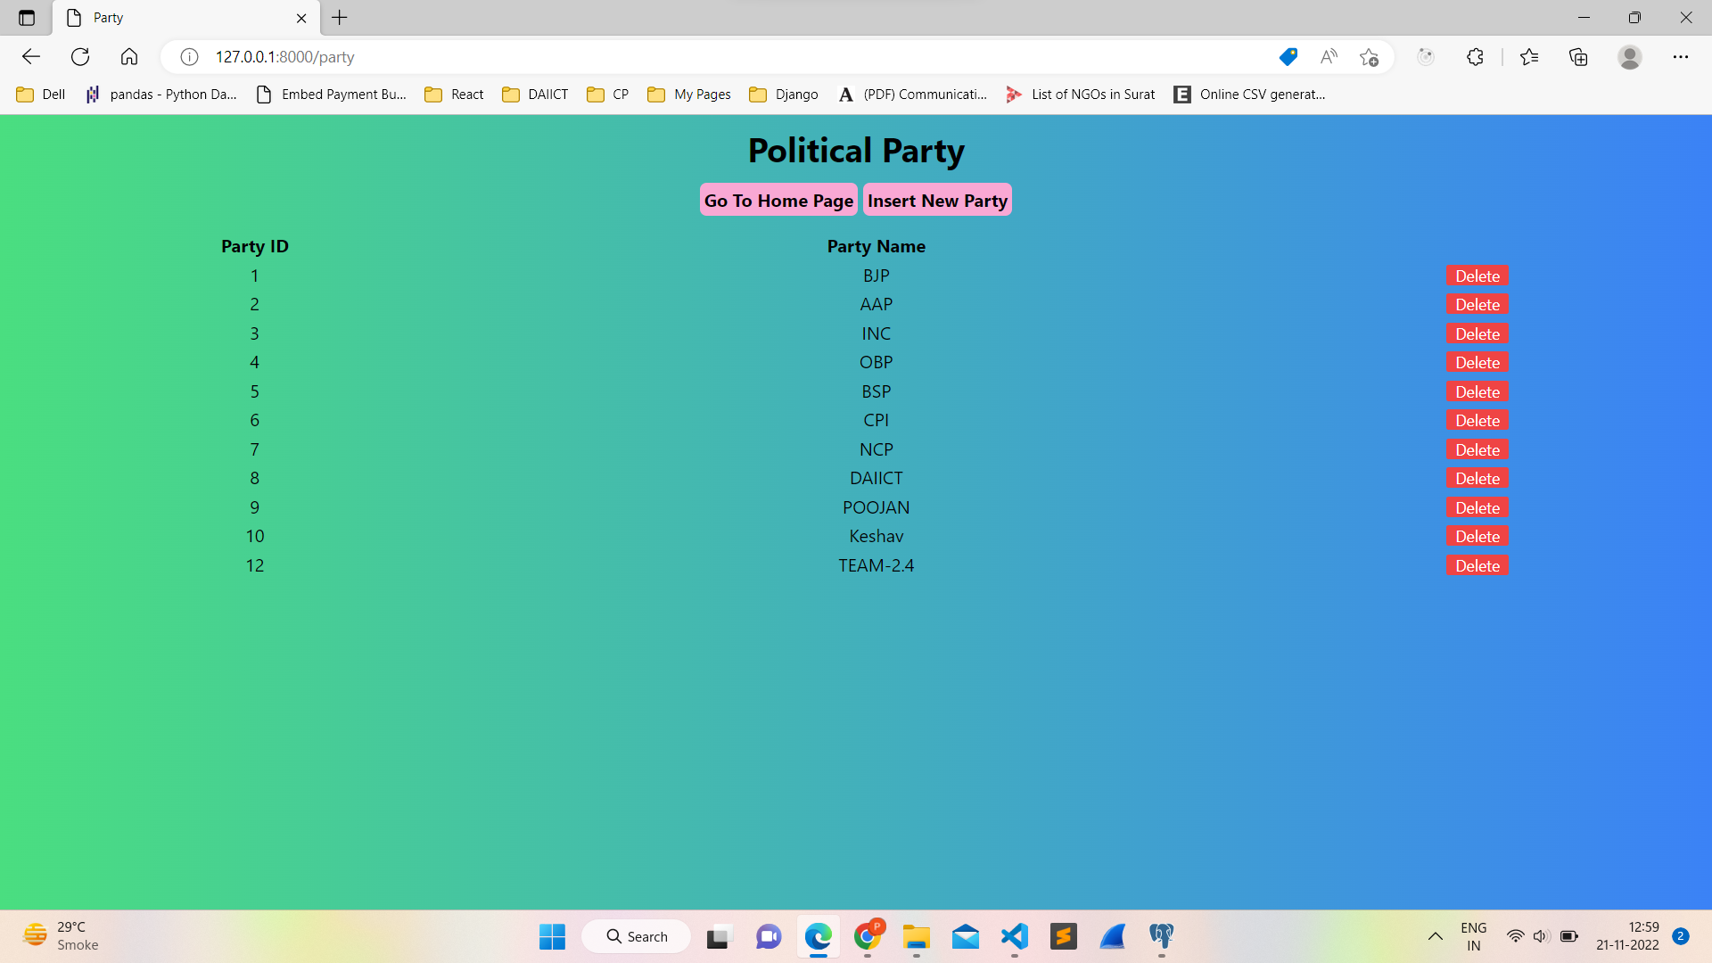

Deleting party with party ID 12,

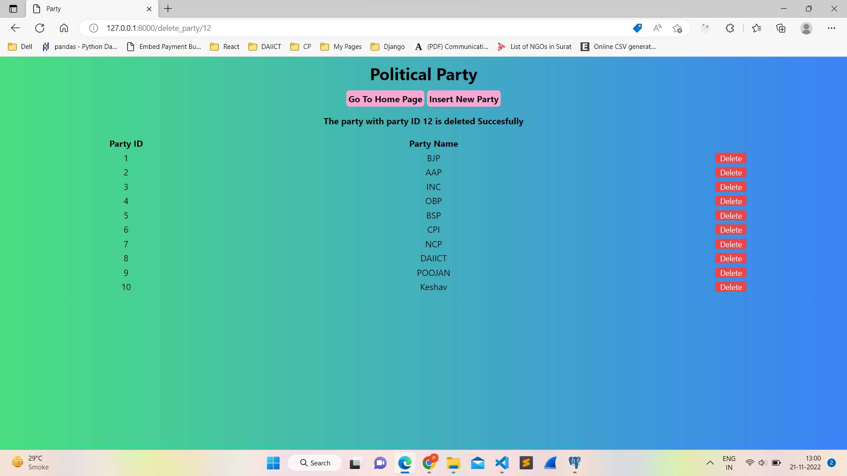

Education minister database:

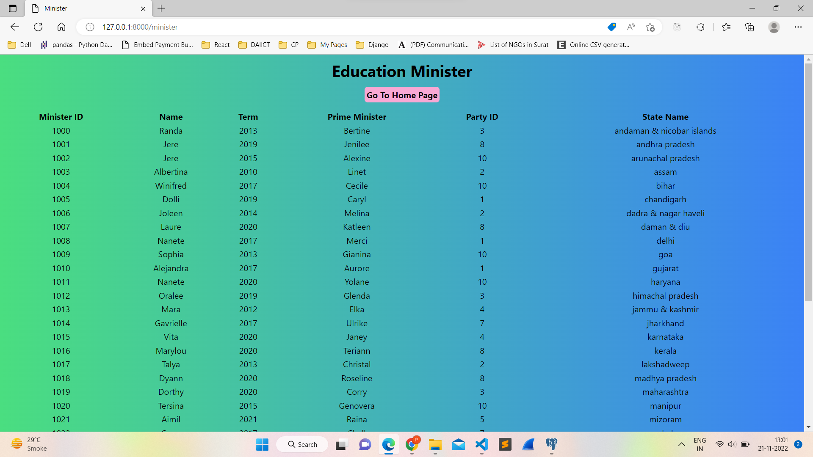

Database of list of all schools:

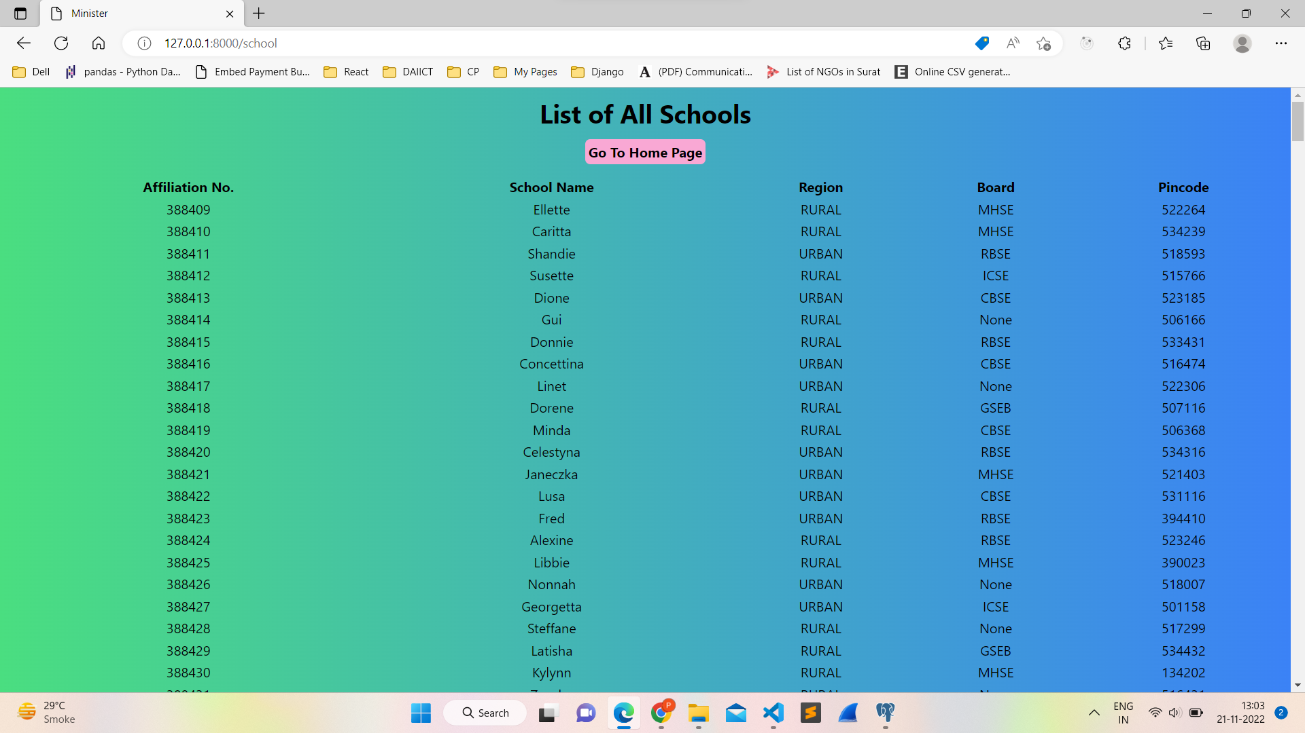

Database of student:

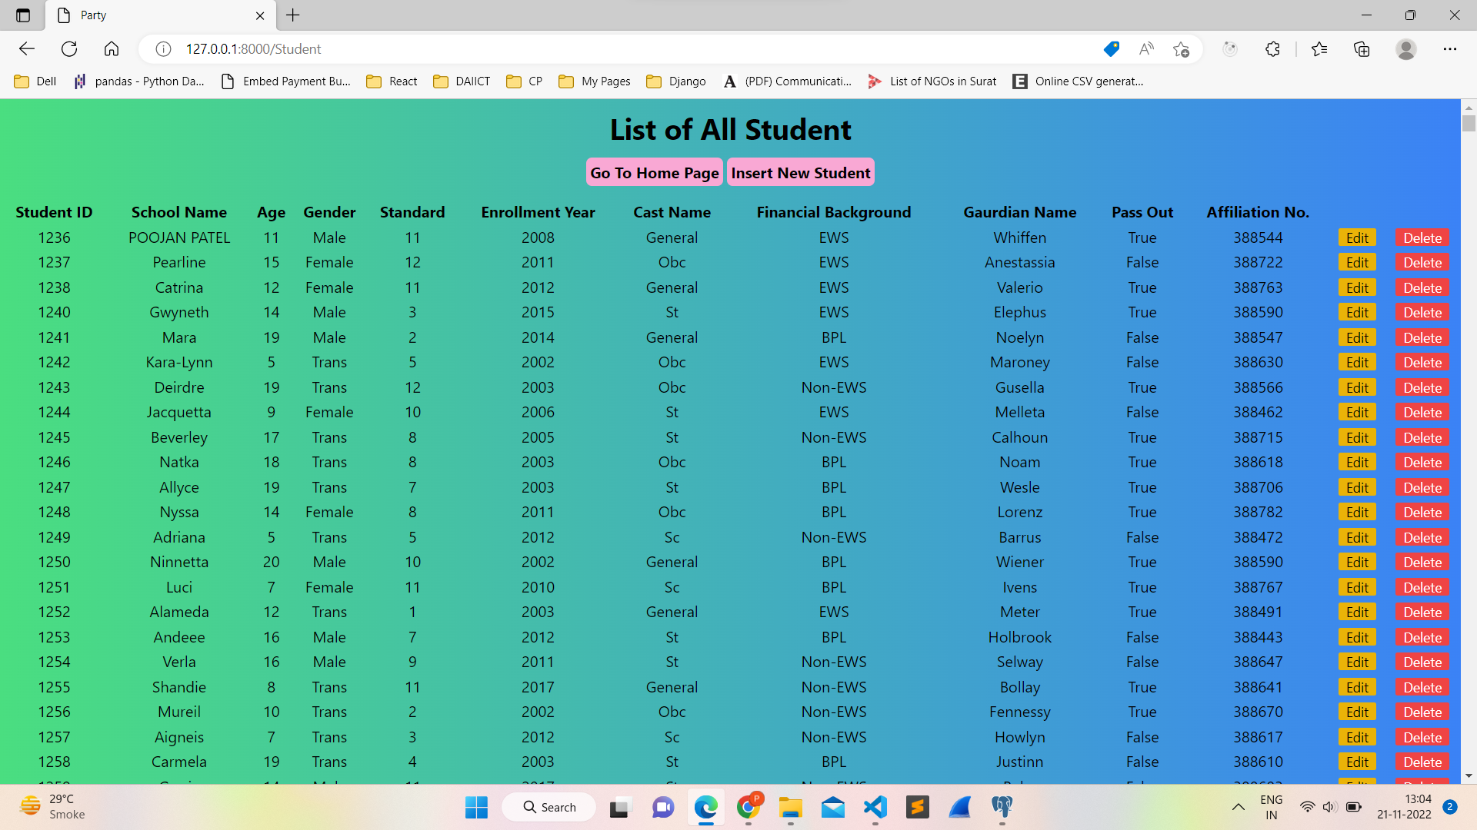

Inserting the student with student ID 1

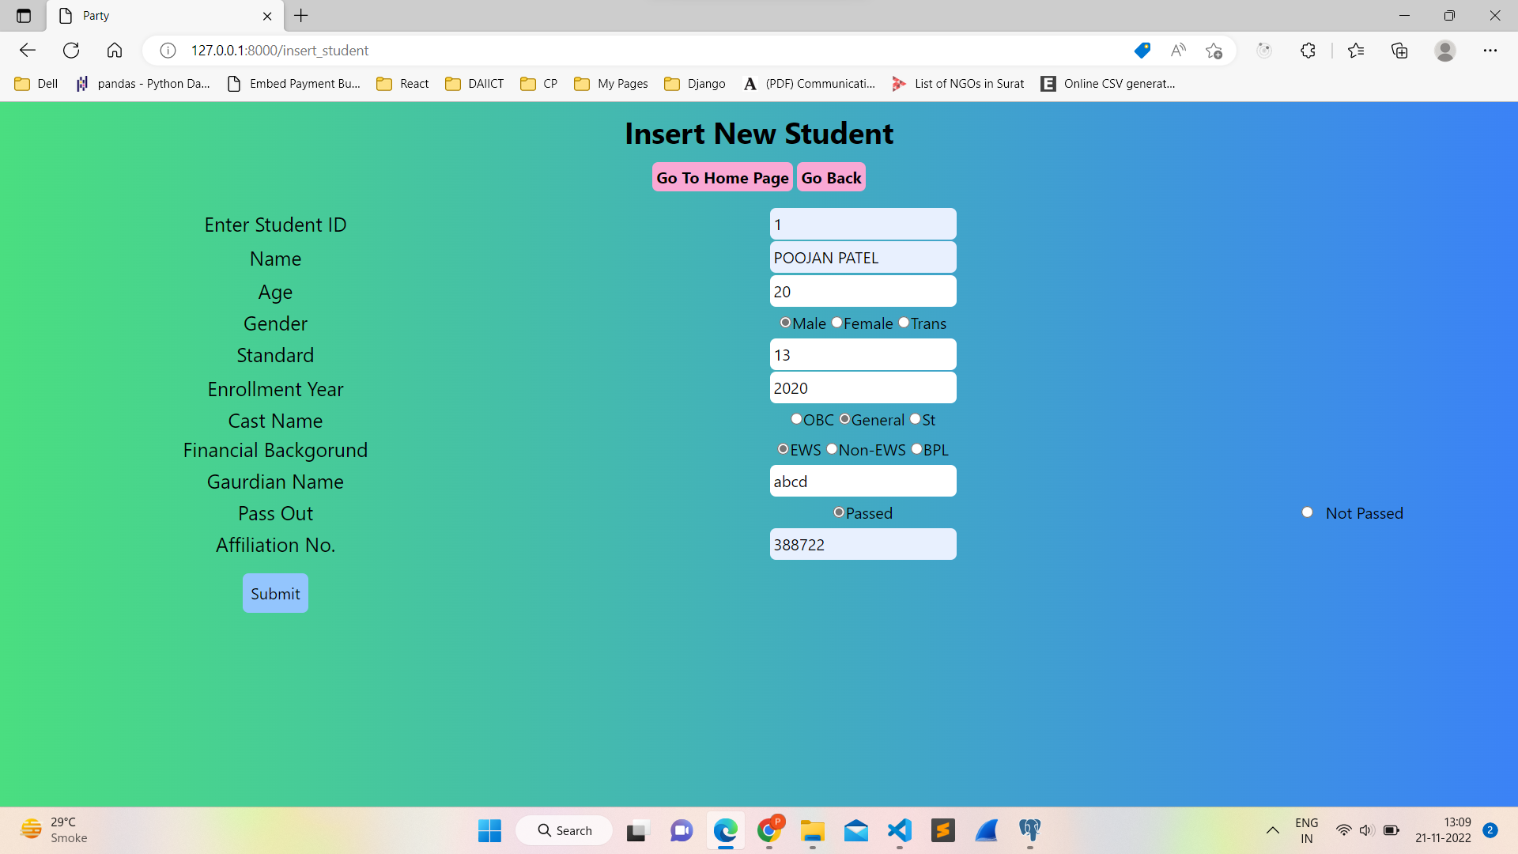

New view of database after inserting new student:

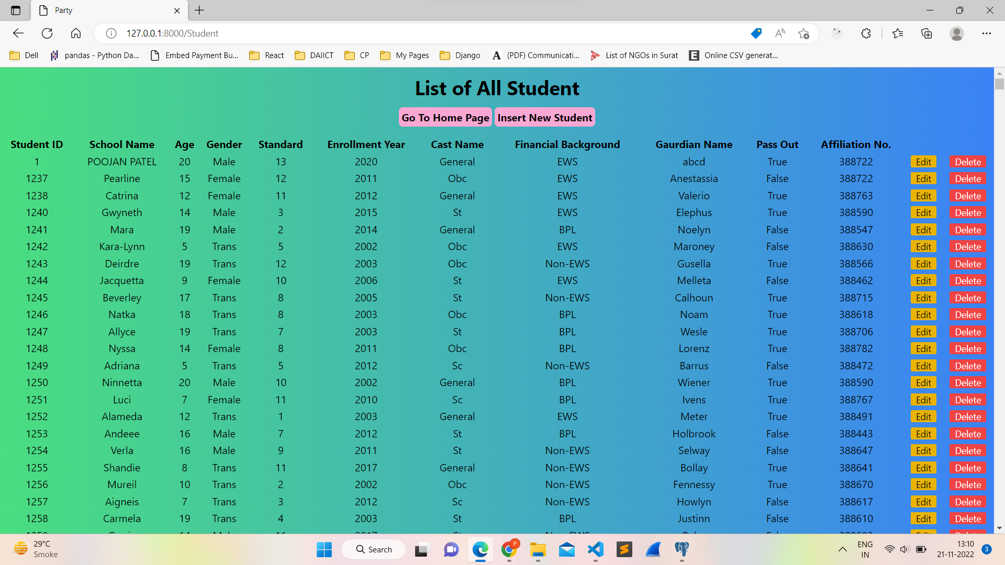

Updating the information of student with student ID 1:

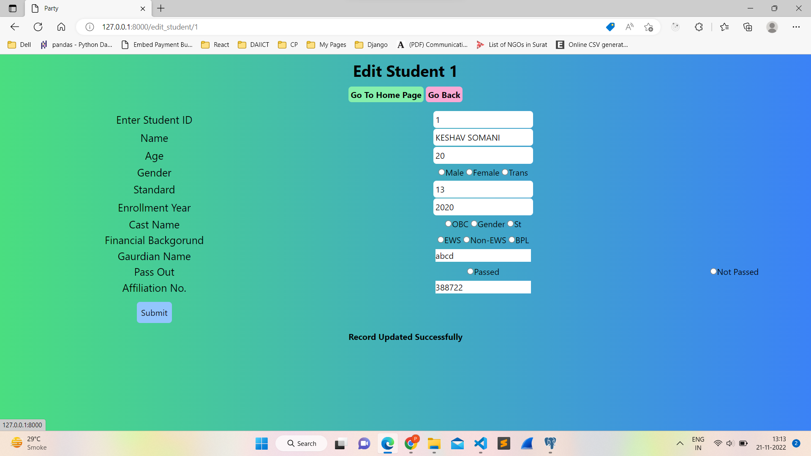

New view of database:

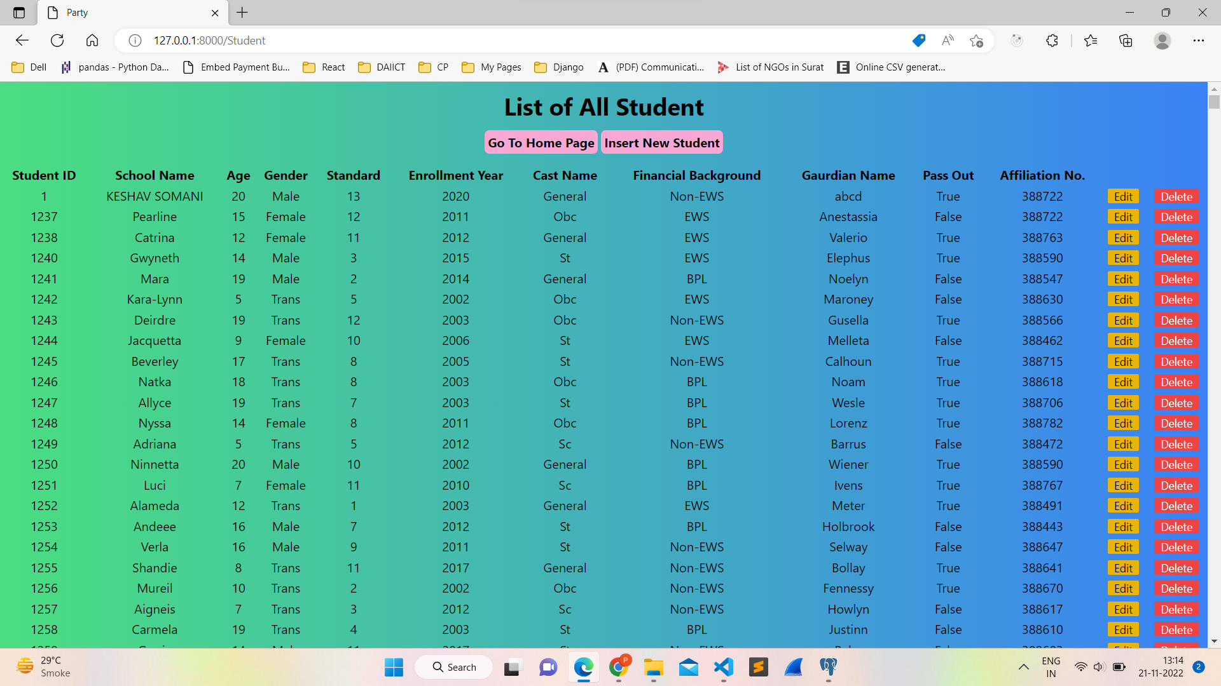

Deleting student with student ID 1

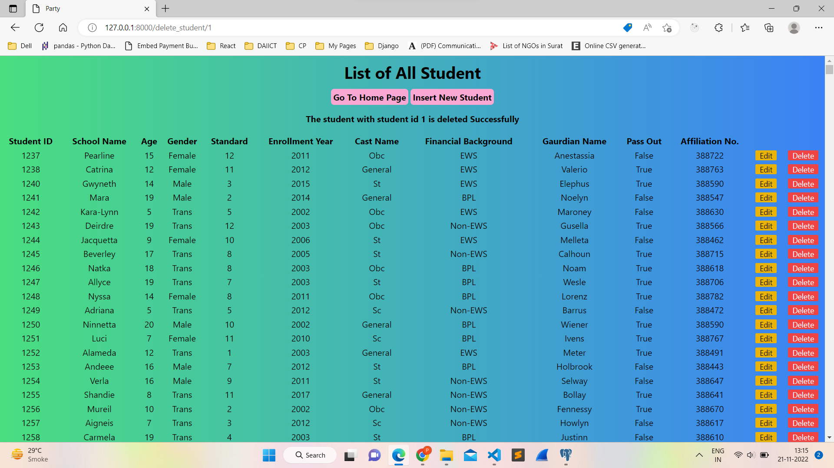

[Github repository for this project.](https://github.com/poojan021102/education_minister/settings)